**Garage Management system**

College Name: Tirupur Kumaran College for women

College Code: bru3j

Team ID: NM2025TMID28418

Team Members: 4

Team Leader Name: Archana. M

Email: archanamurugan708@gmail.com

Team Member1: Banu Priya.M

Email: banusuresh2006@gmail.com

Team Member2: Megala.S

Email: megalasuresh1631@gmail.com

Team Member3: Shalini.T

Email: shalinit648@gmail.com

**1.INTRODUCTION**

**Project Overview**

The Garage Management System is a valuable tool for automotive repair facilities, helping them deliver top-notch service, increase operational efficiency, and build lasting customer relationships. With its user-friendly interface and powerful features, GMS empowers garages to thrive in a competitive market while ensuring a seamless and satisfying experience for both customers and staff.

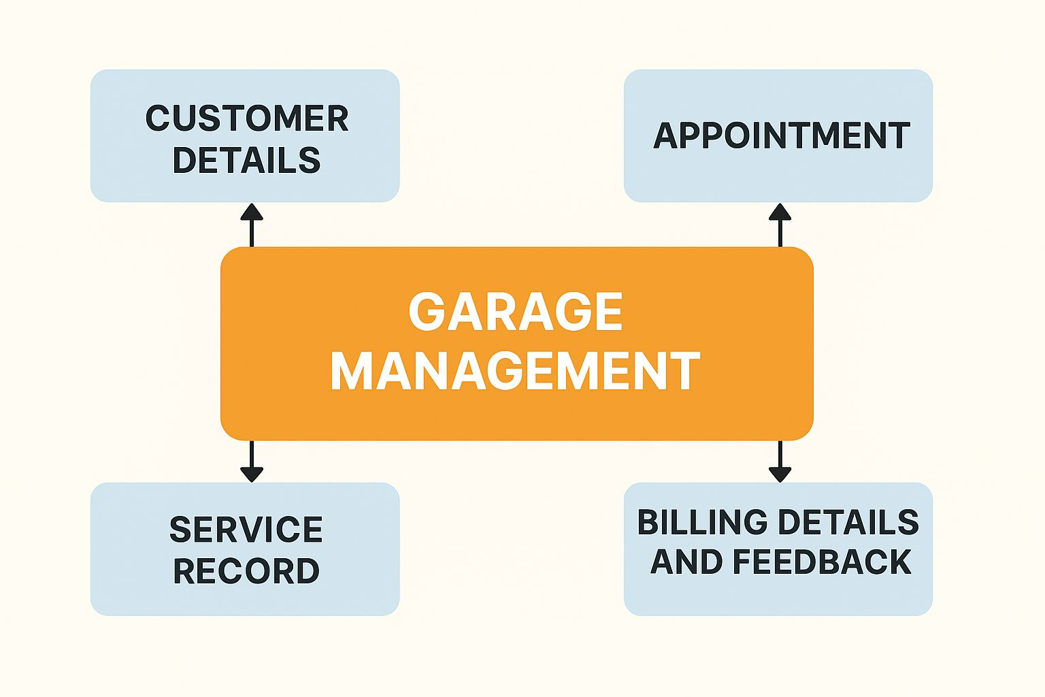

**1.2 Purpose**

The purpose of a Garage Management System is to streamline and automate the operations of a vehicle service center. It ensures efficient management of customer interactions, service scheduling, work progress, billing, and feedback, improving productivity and customer satisfaction.

**DEVELOPMENT PHASE**

**Creating Developer Account:**

1. By using this URL-https://developer.salesforce.com/signup

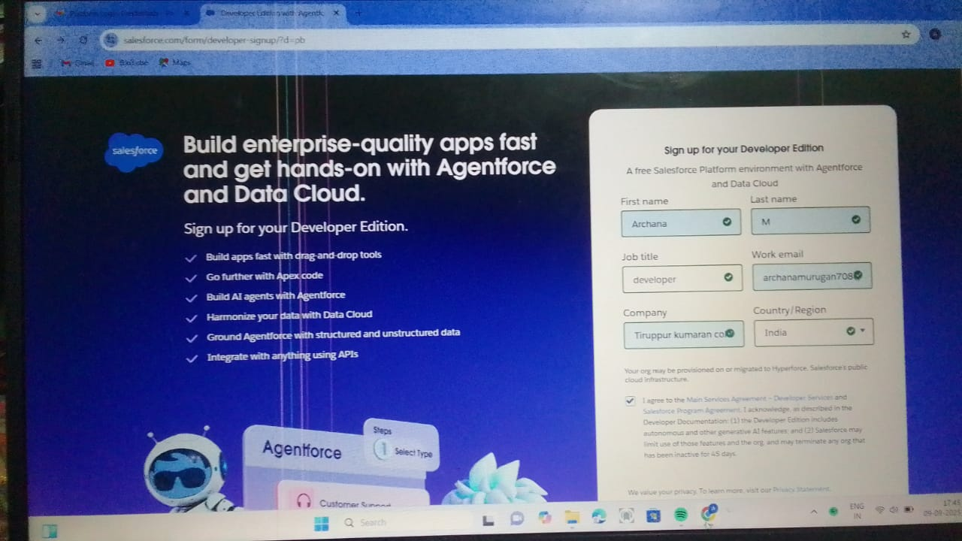

* Created Objects: Customer details,Appointment,Service record,Billing details and feedback.

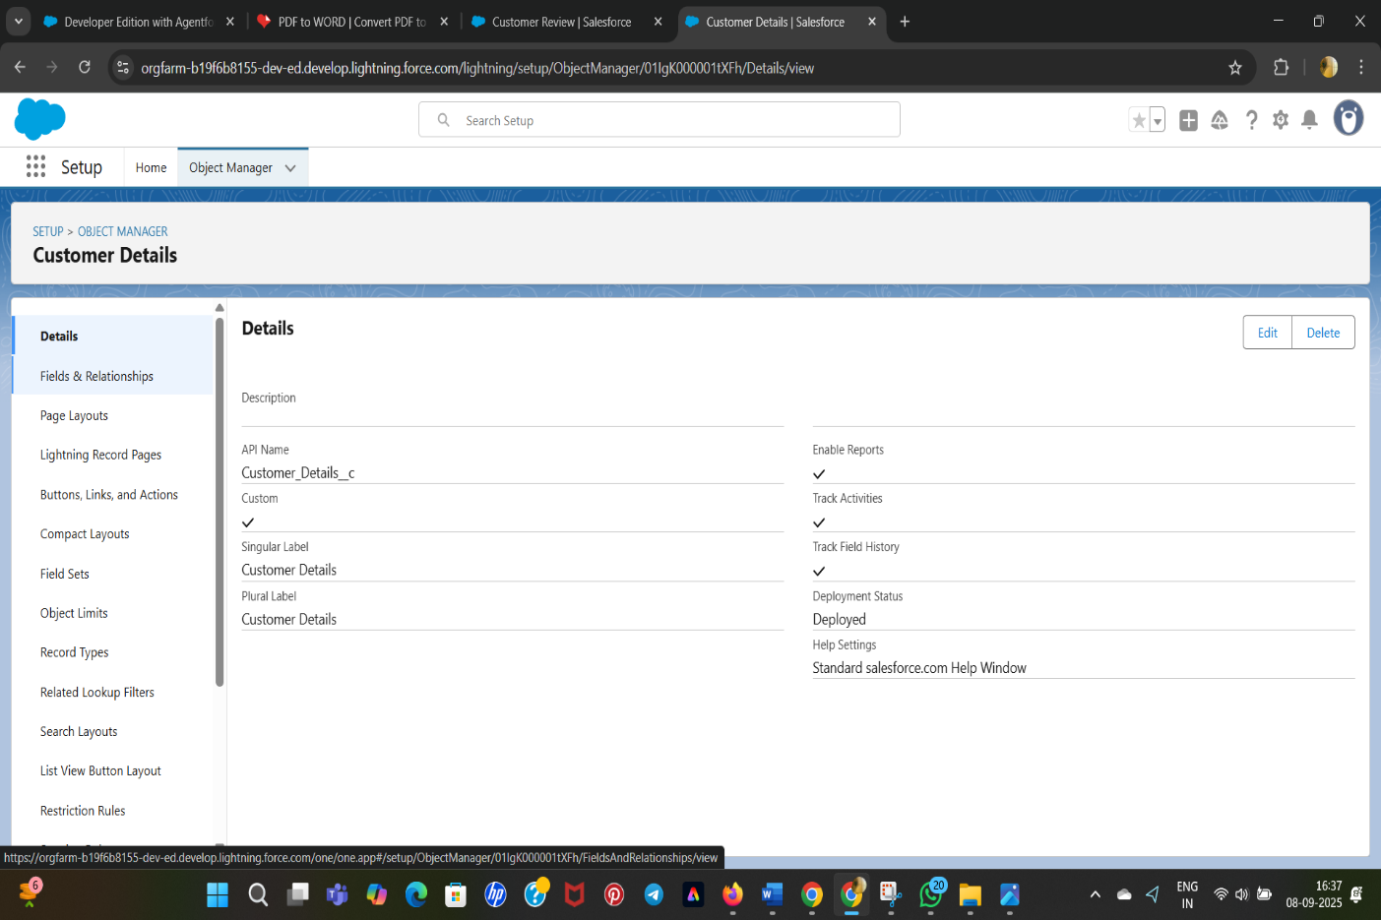

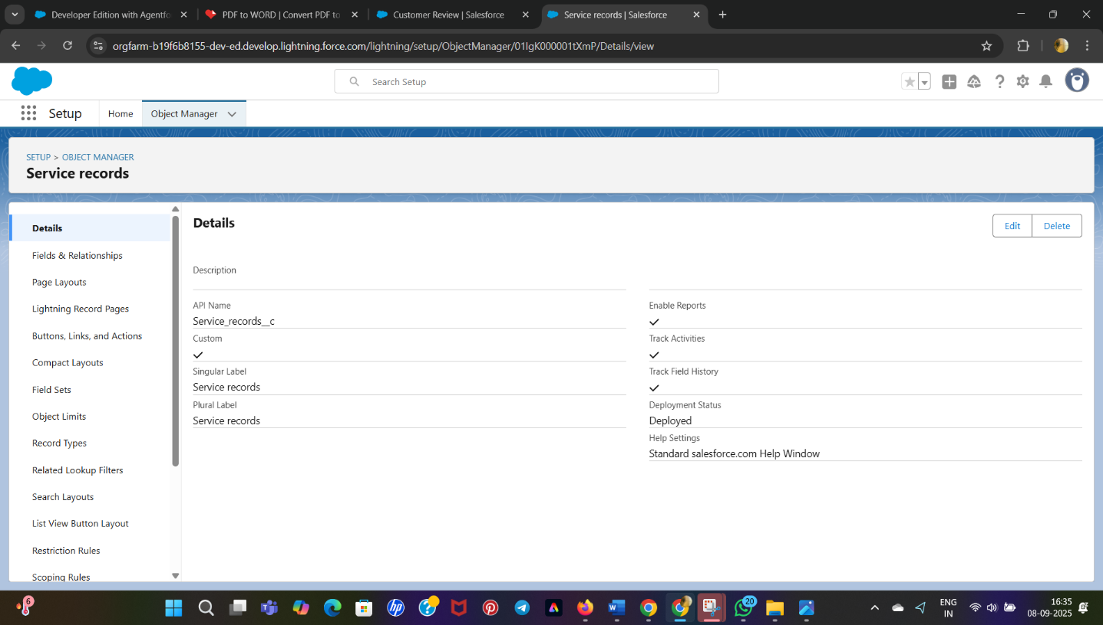

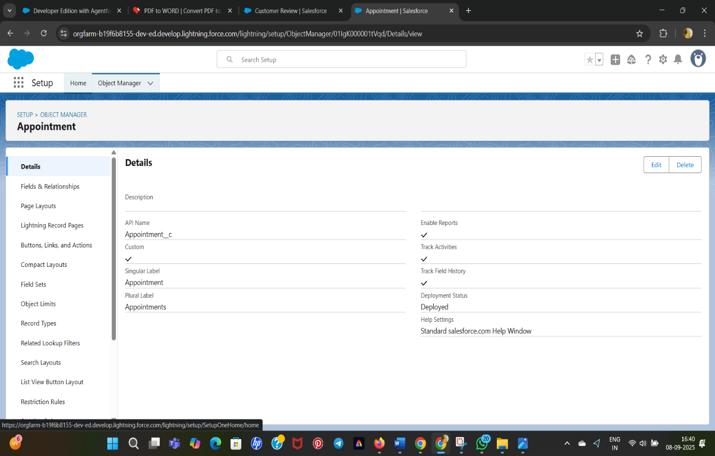

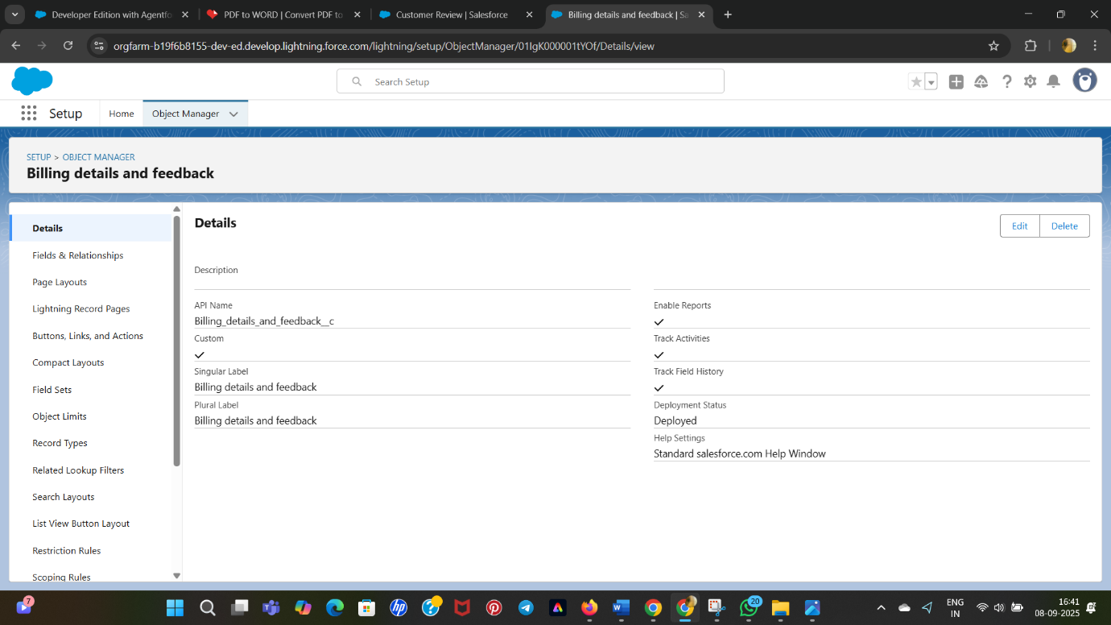

# **TABS**

* Tab is like a user interface that is used to build records for objects and to view the records in the objects.

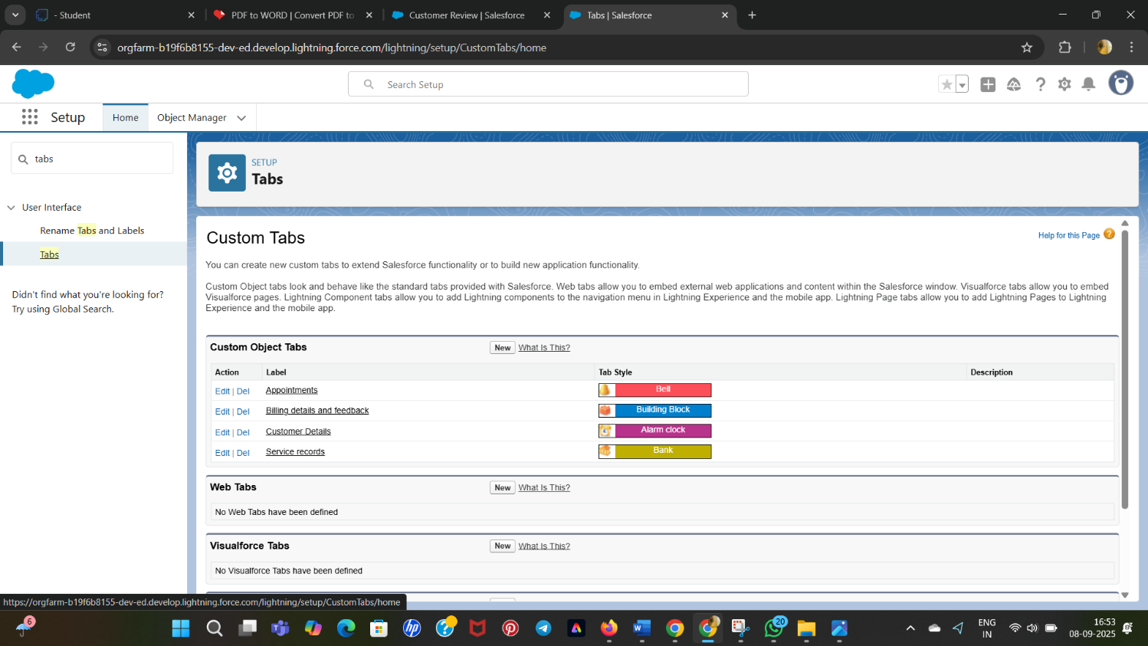

### Create a Lightning App

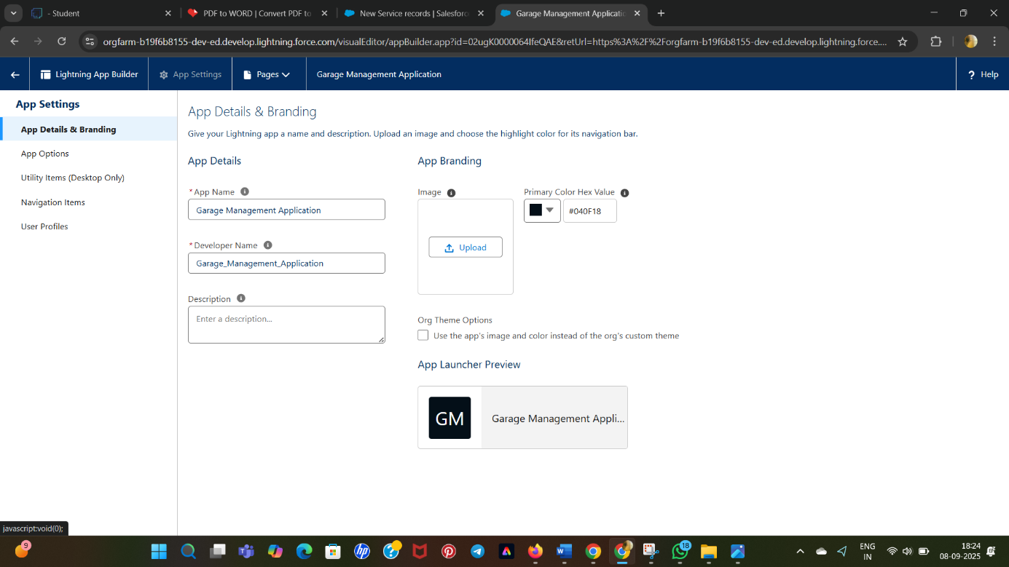

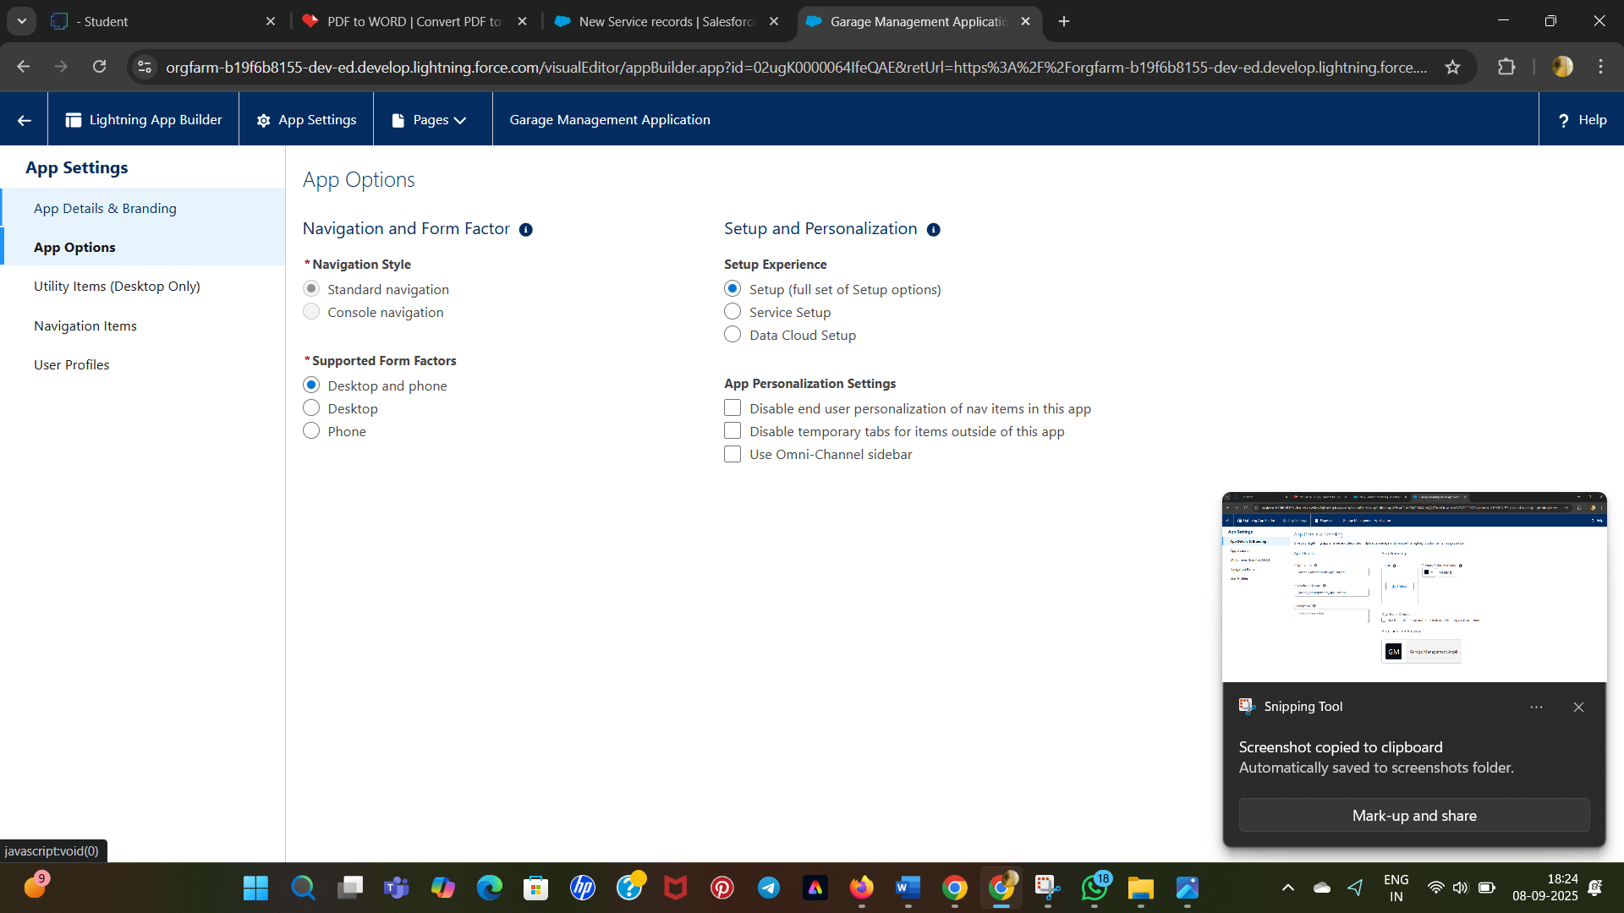

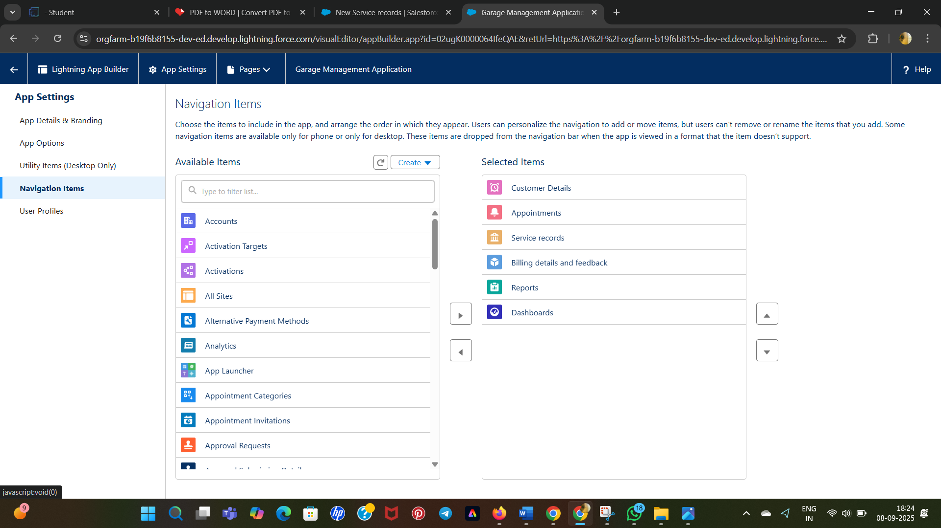

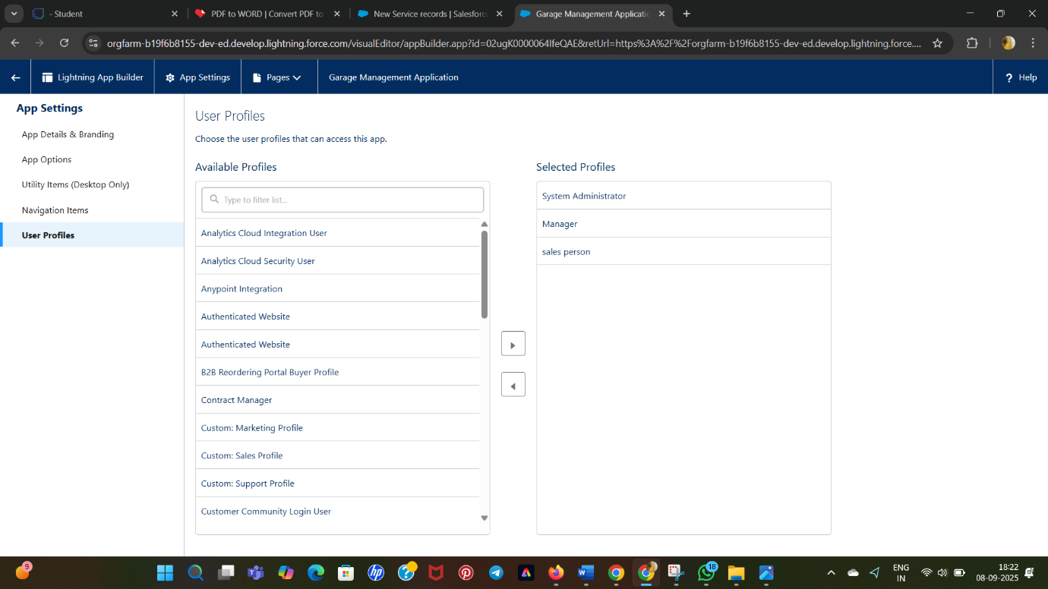

* Created Fields and Relatioships for objects:

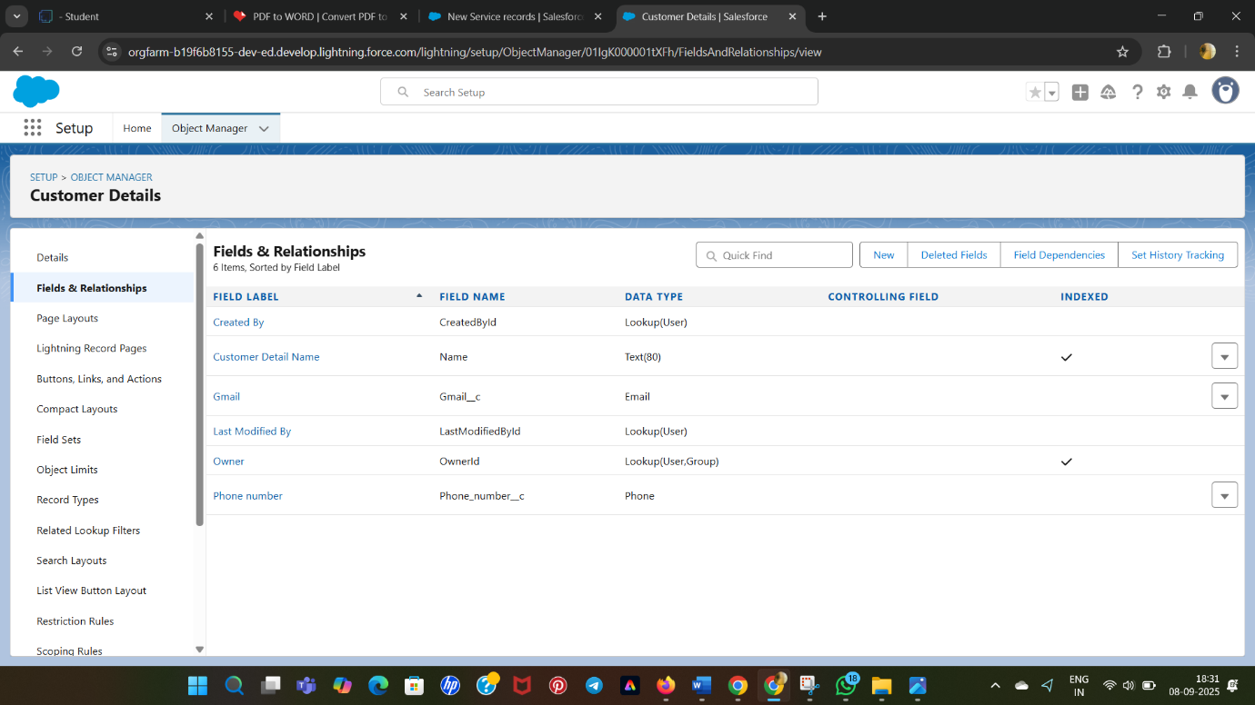

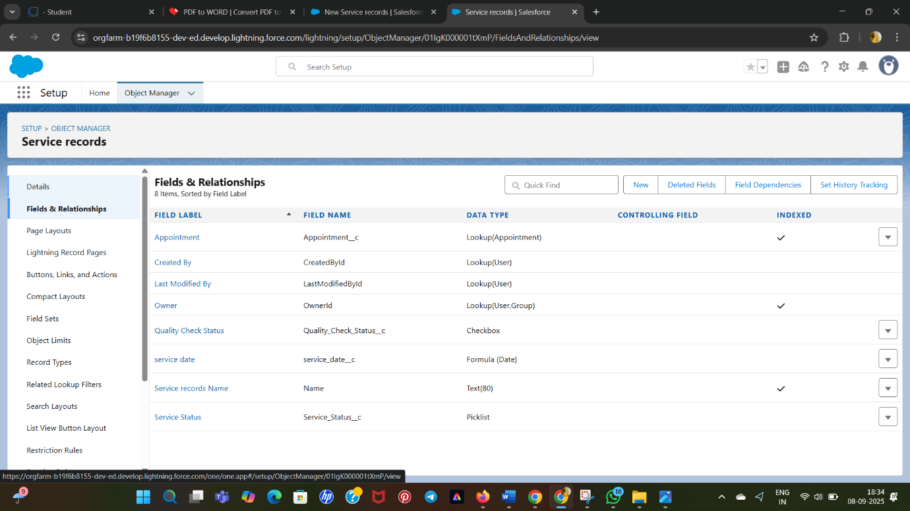

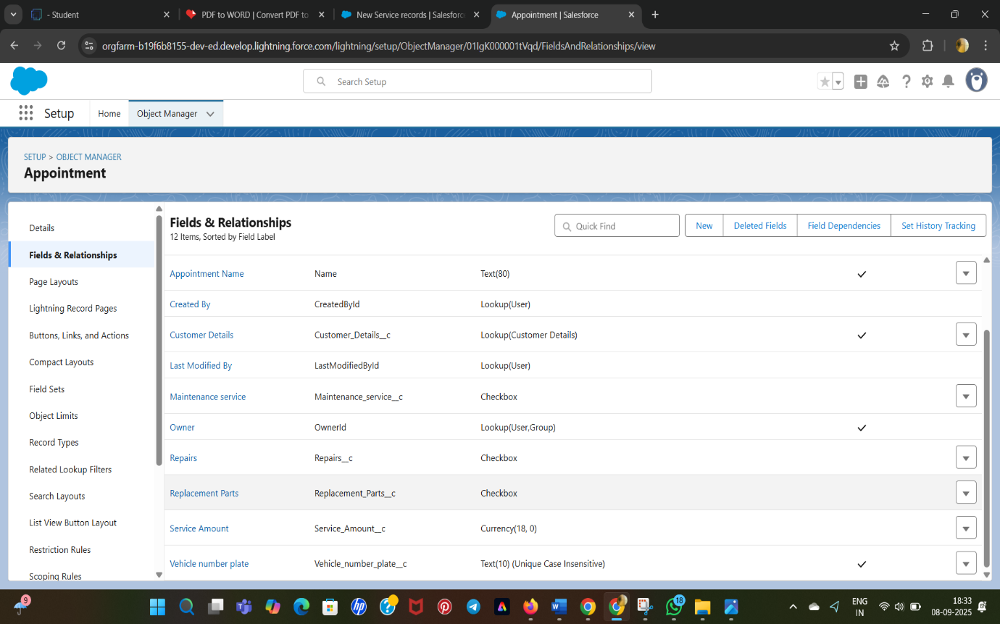

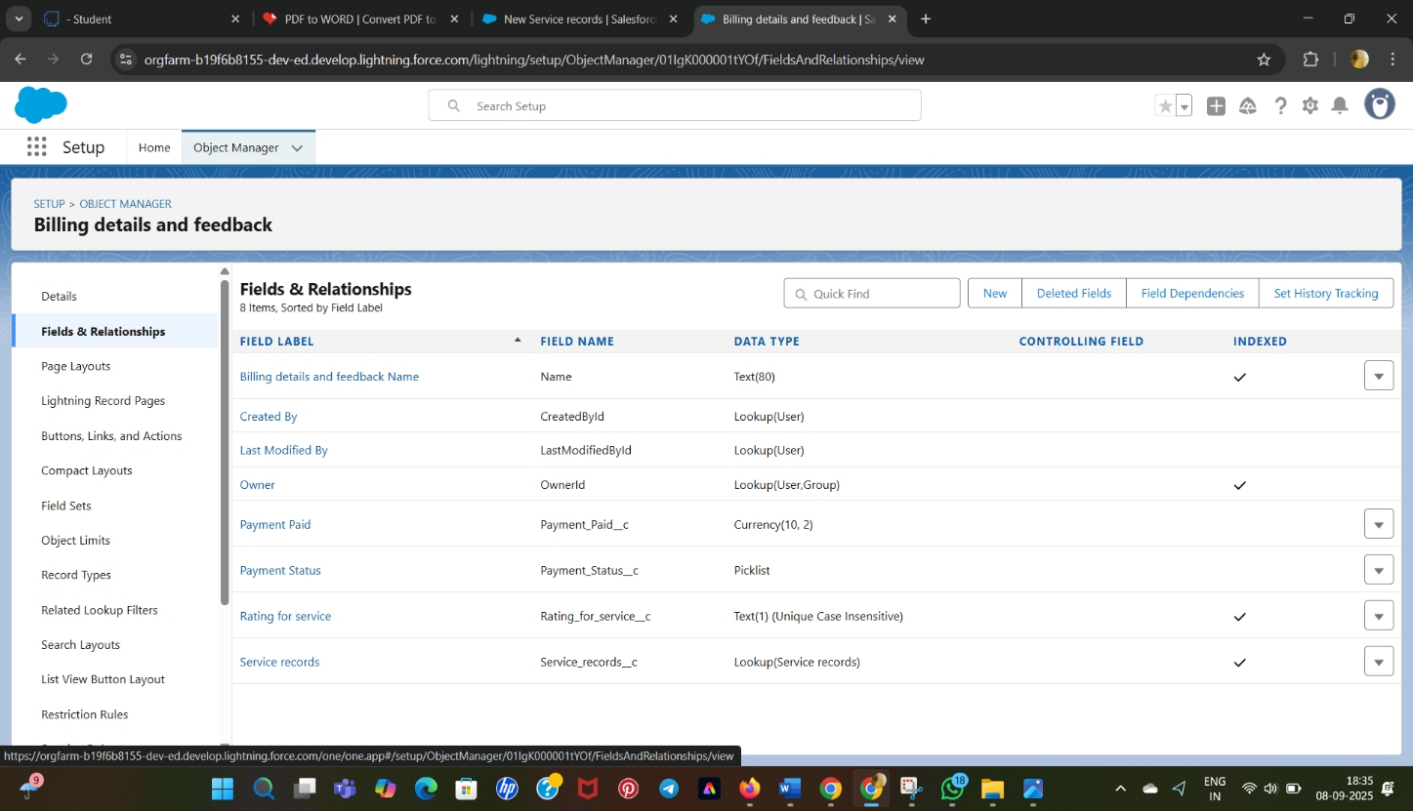

* Validation Rules:
* Validation rules are applied when a user tries to save a record and are used to check if the data meets specified criteria.
* To create a validation rule to an Appointment Object:

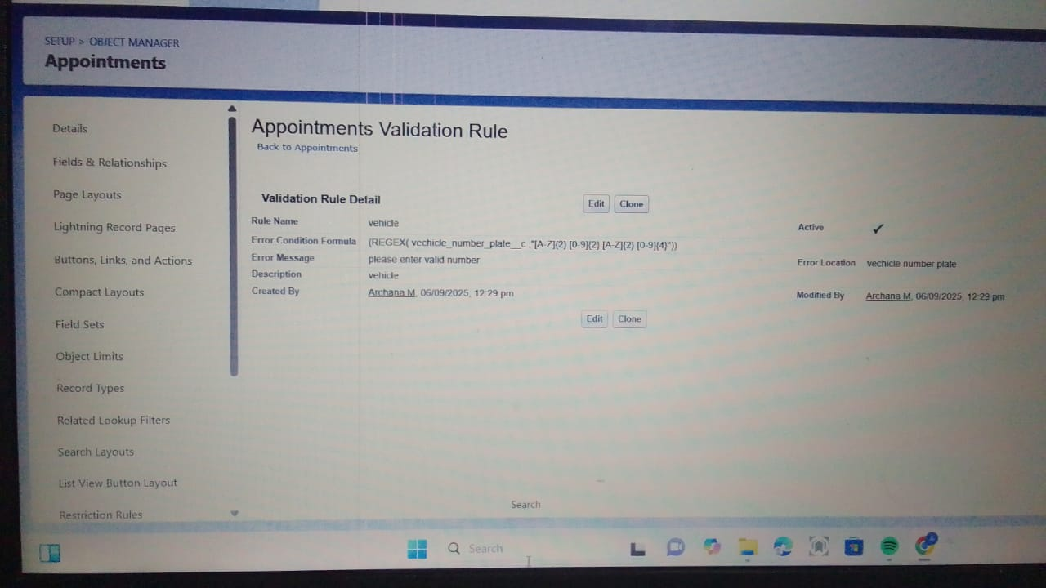

### To create a validation rule to an Billing details and feedback Object:

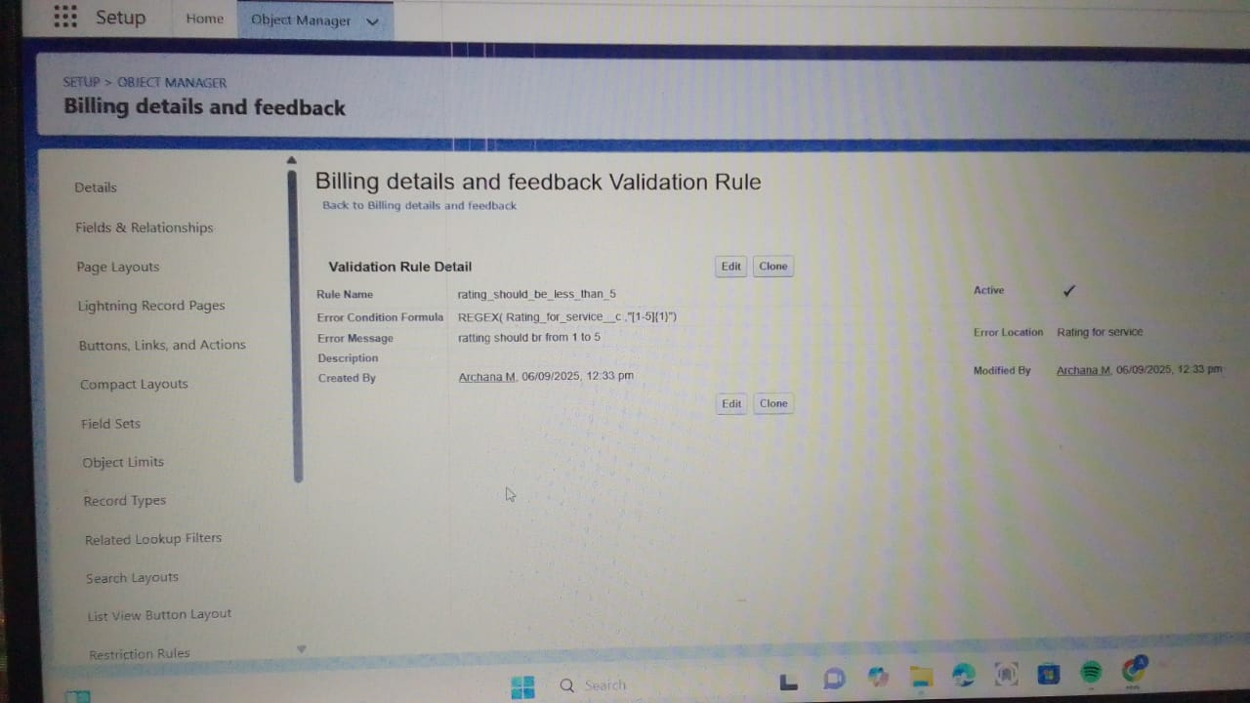

### create a matching rule to an Customer details Object:

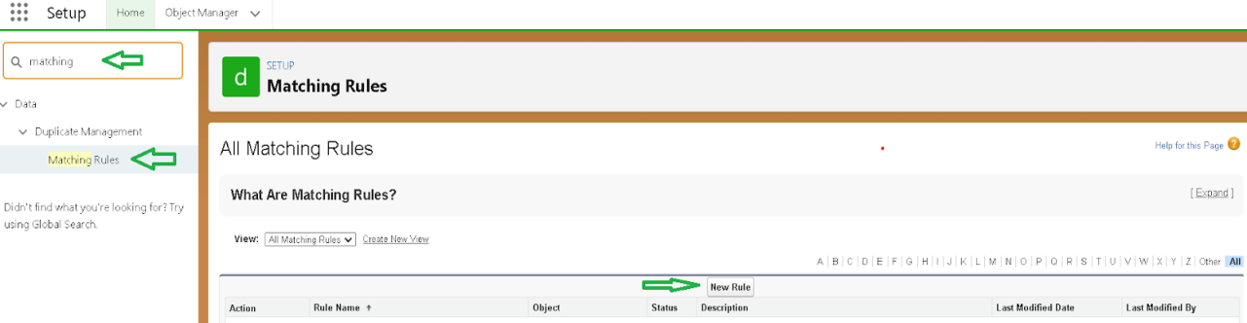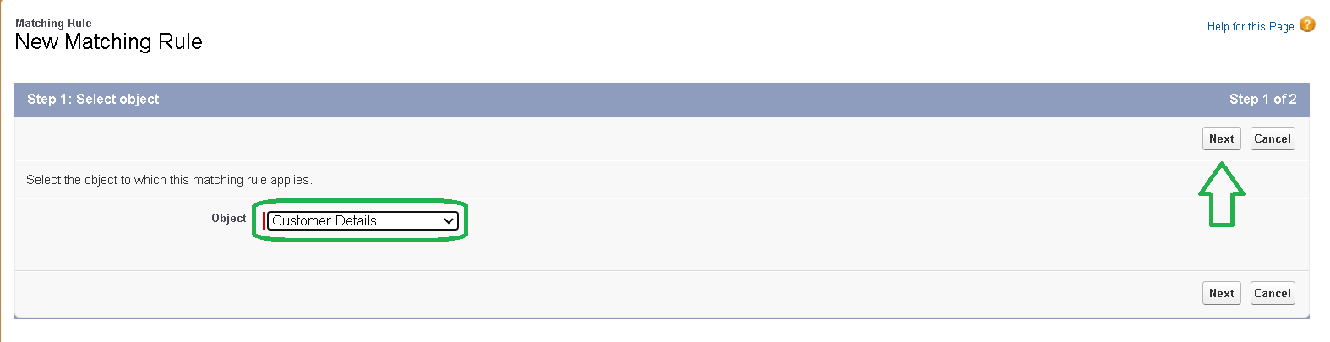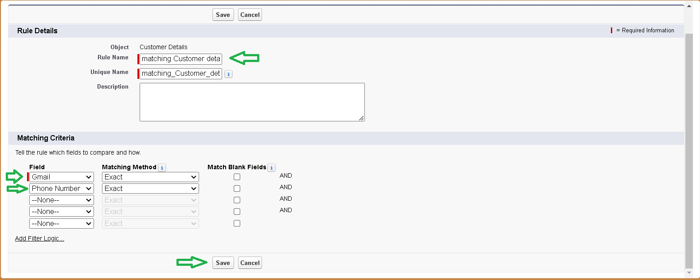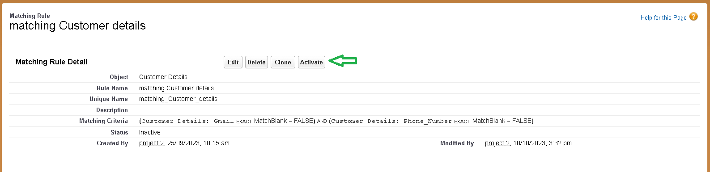

### create a Duplicate rule to an Customer details Object:

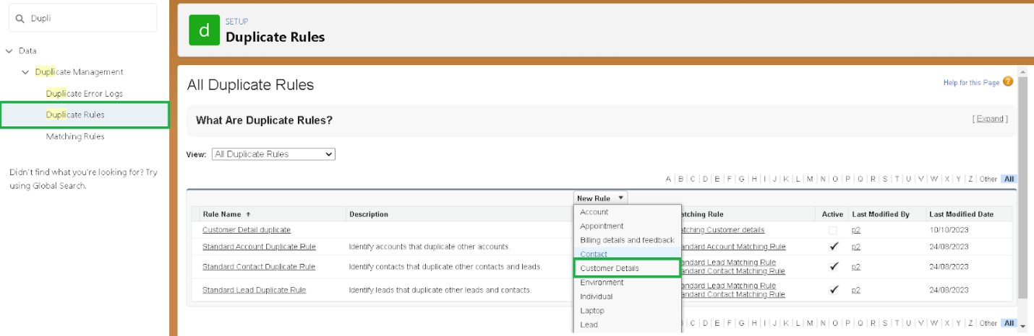

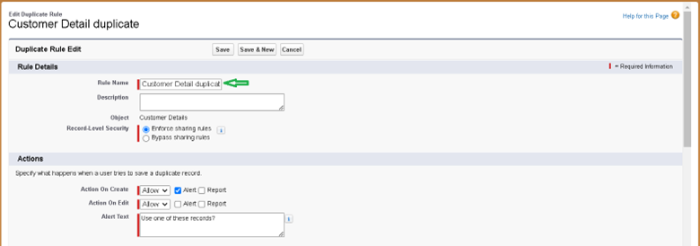

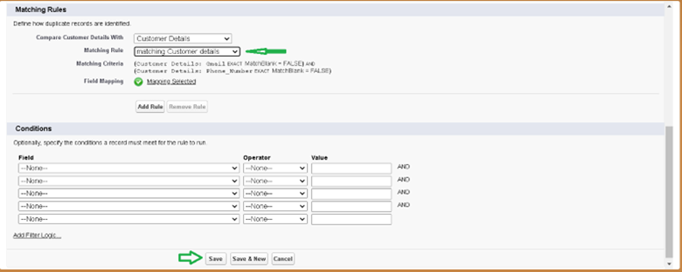

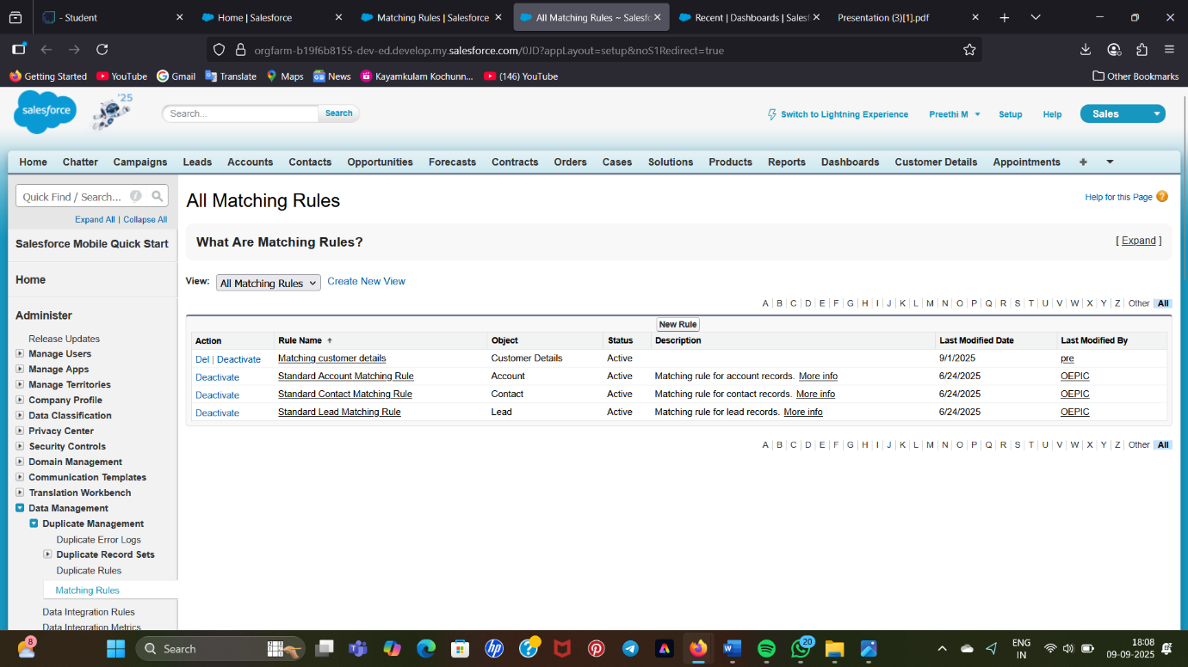

* **To create a new profile:**

Manager Profile

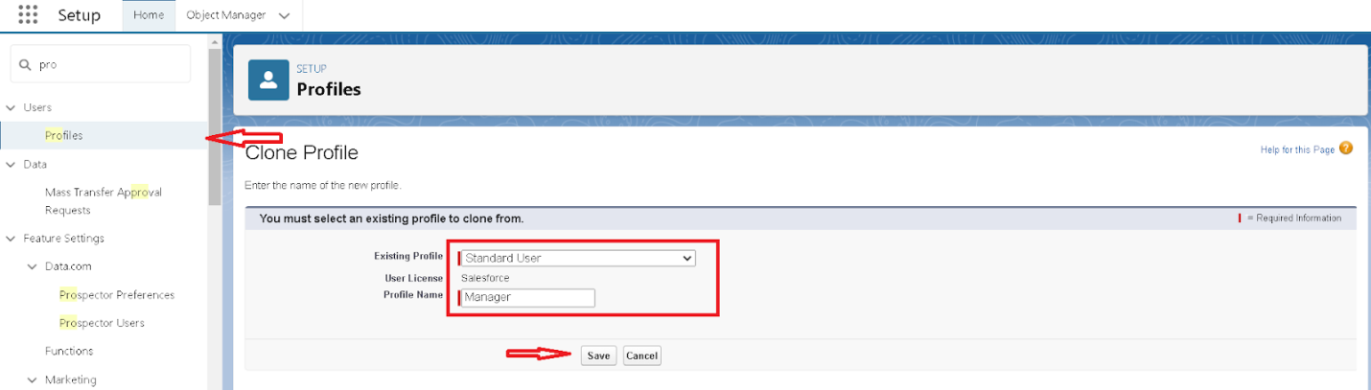

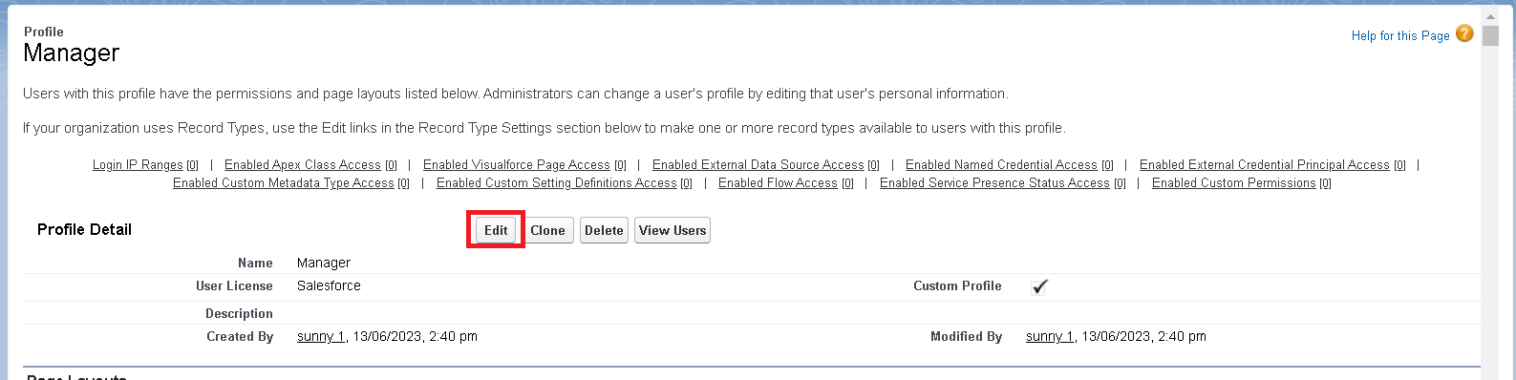

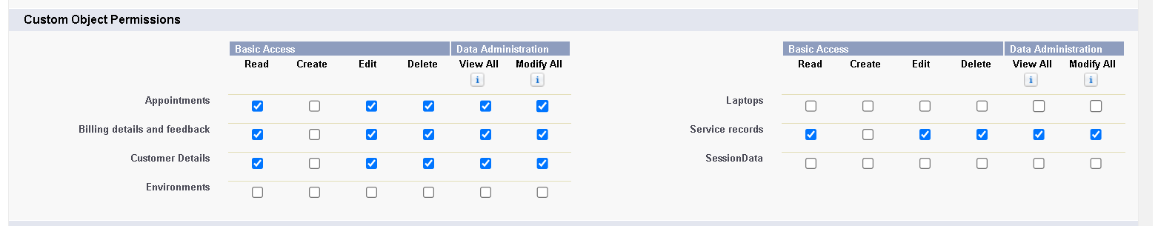

Sales person Profile

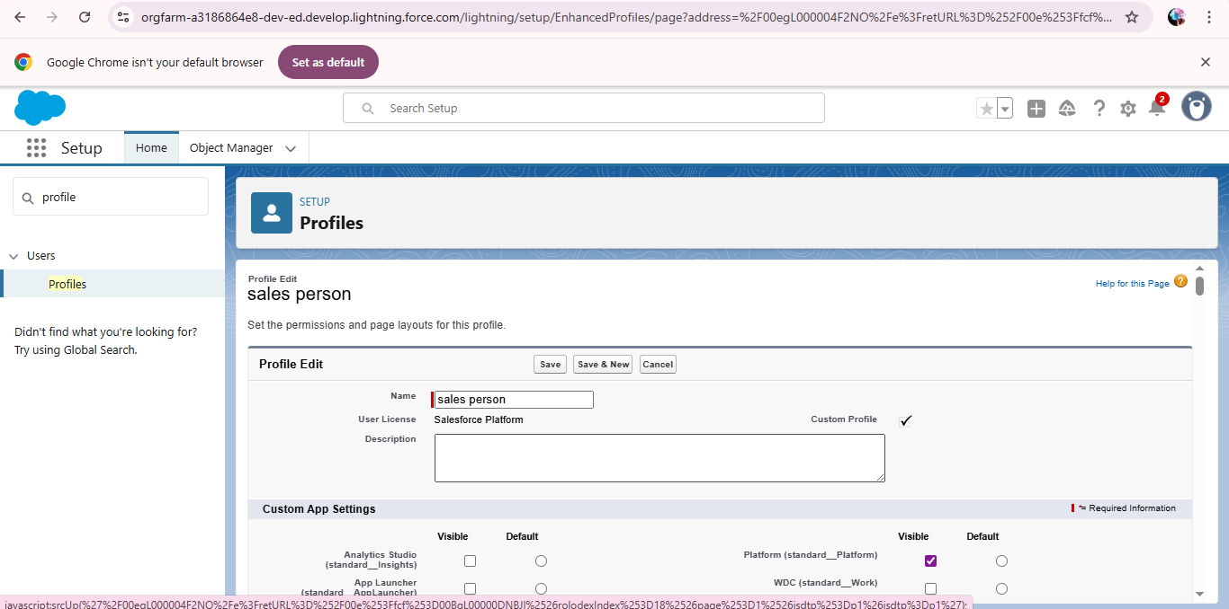

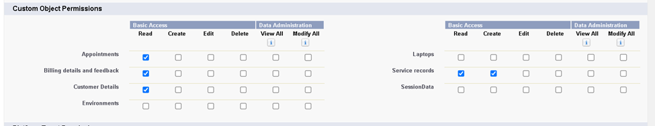

### Creating Manager Role:

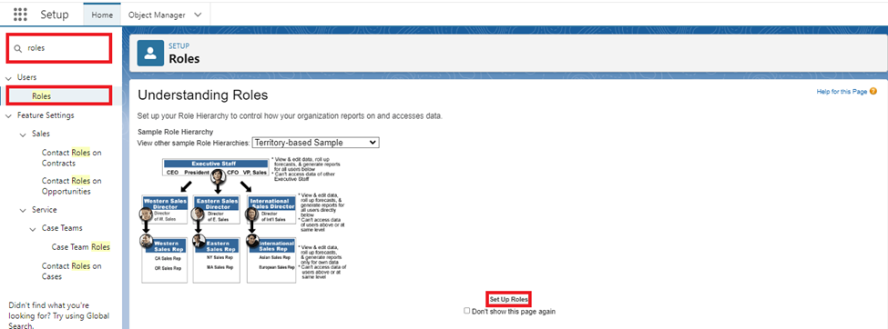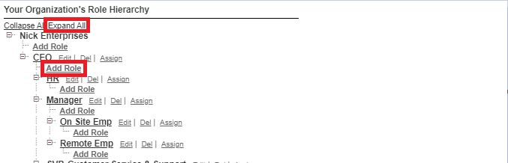

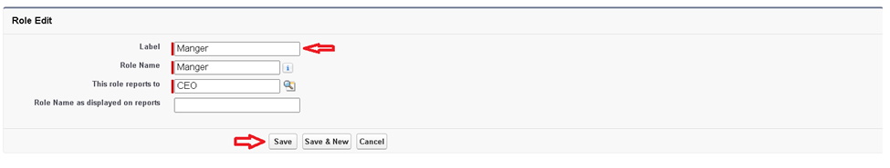

### Creating another roles :

### Create User:

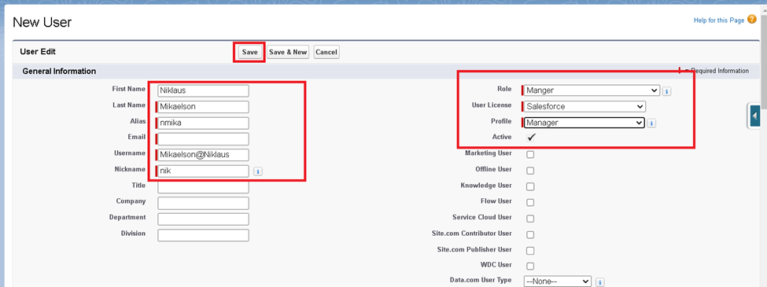

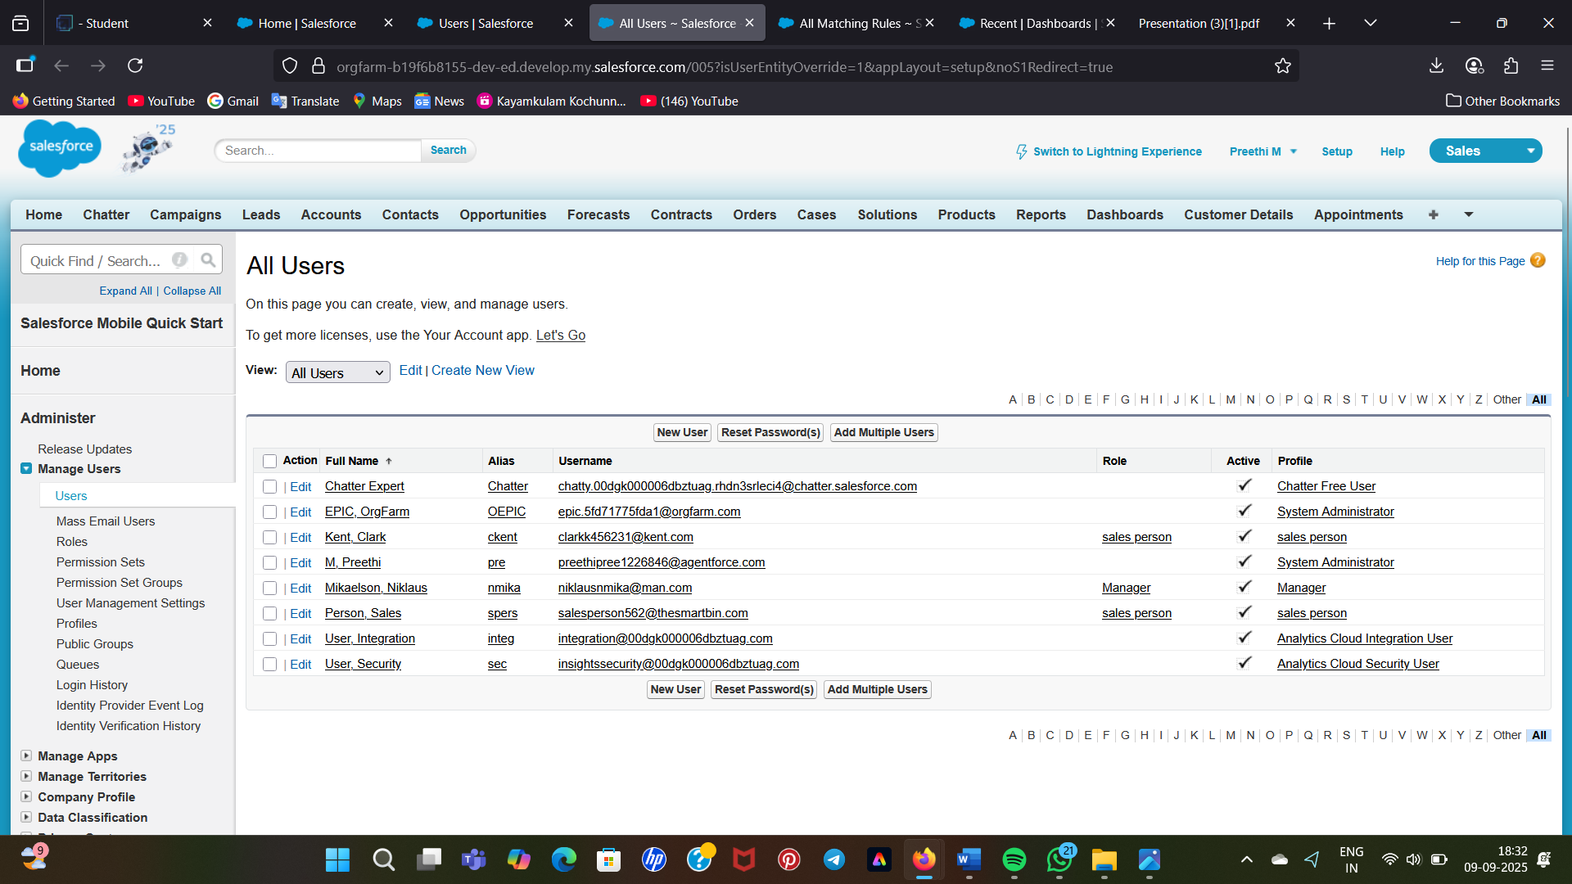

### Creating New Public Group:

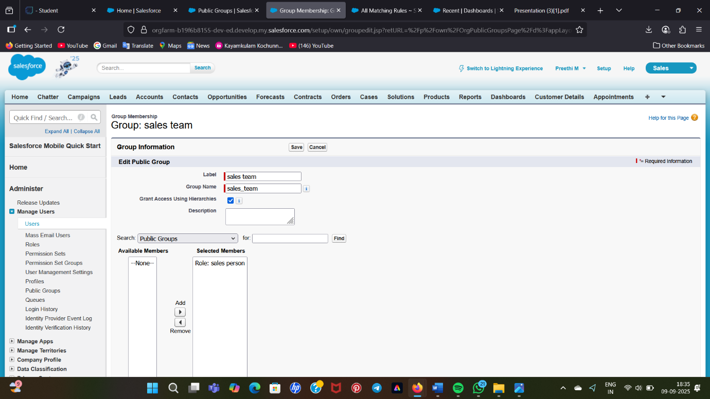

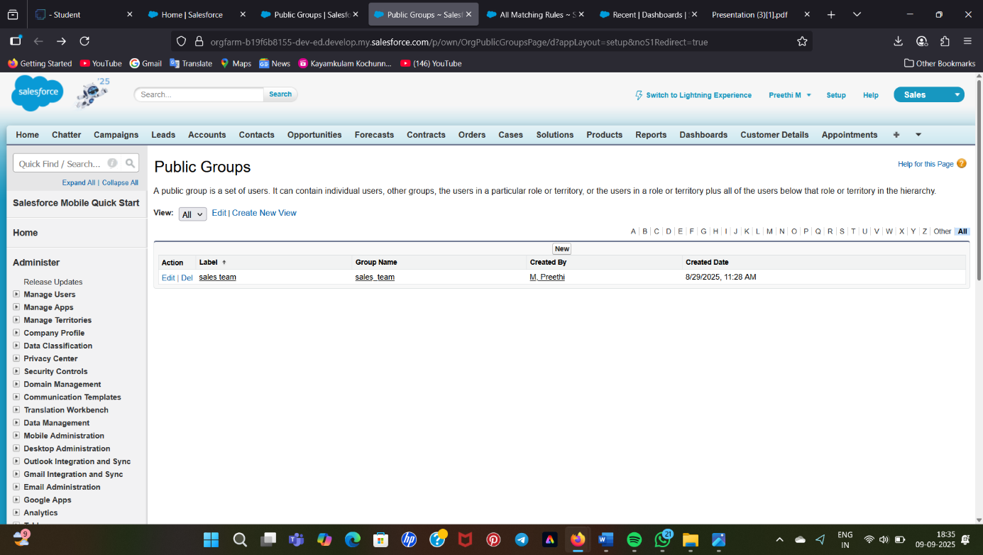

### Creating Sharing settings:

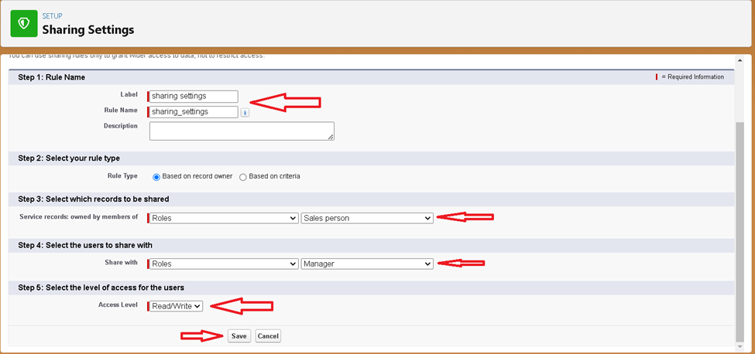

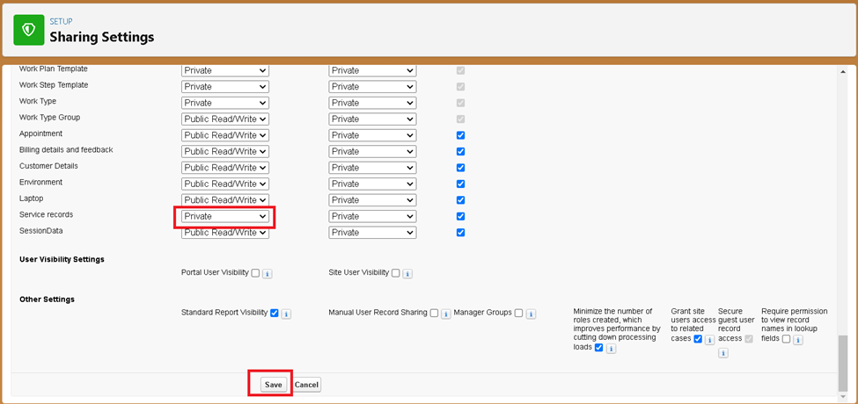

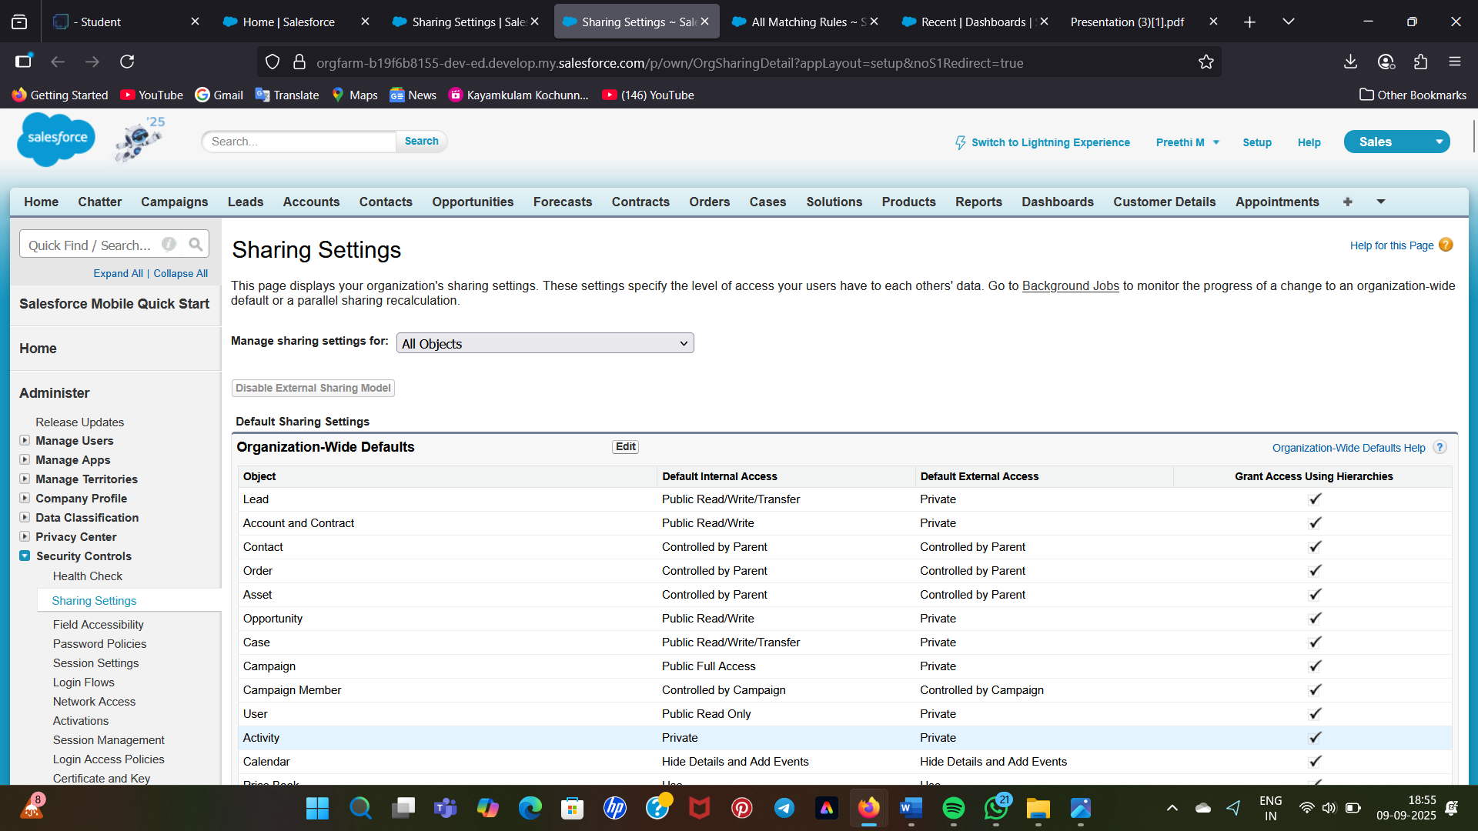

* **Create a Flow**

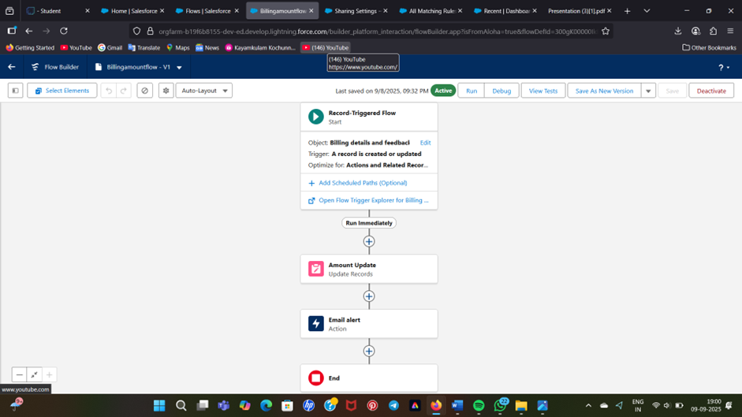

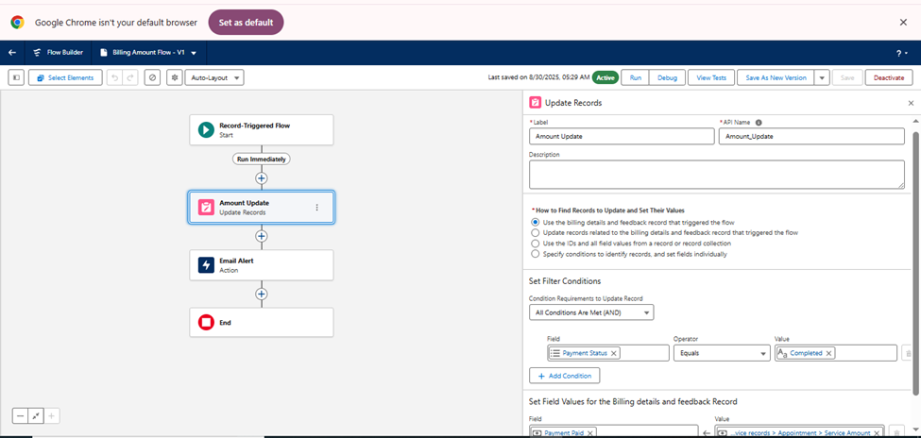

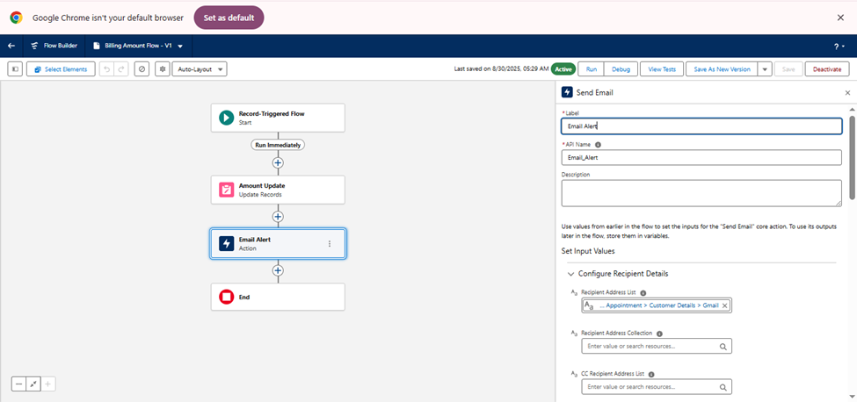

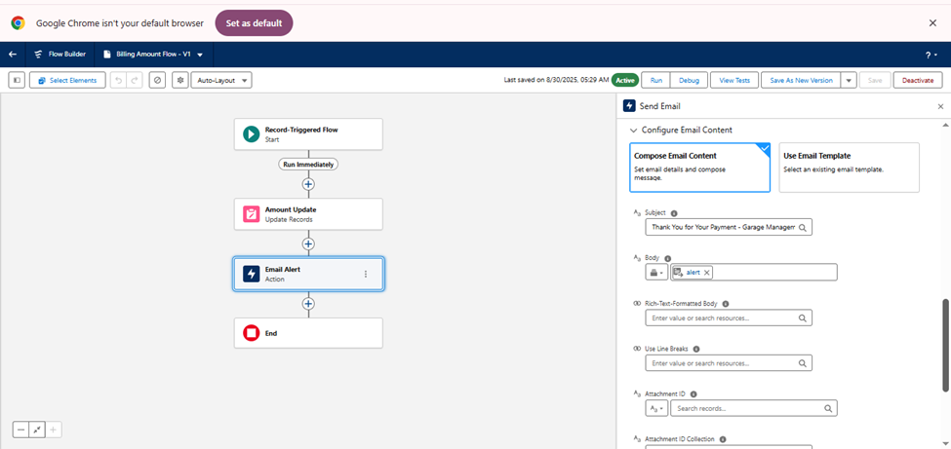

* Created Another Flow

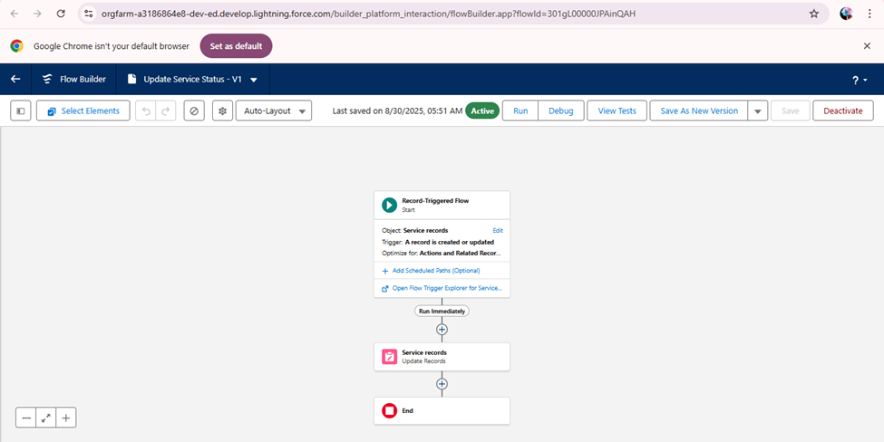

**Apex Trigger**

There are primarily two types of Apex Triggers:

* **Before Trigger:** This type of trigger in Salesforce is used either to update or validate the values of a record before they can be saved into the database. So, basically, the before trigger validates the record first and then saves it. Some criteria or code can be set to check data before it gets ready to be inserted into the database.
* **After Trigger:**This type of trigger in Salesforce is used to access the field values set by the system and affect any change in the record. In other words, the after trigger makes changes to the value from the data inserted in some other record.

AmountDistribution

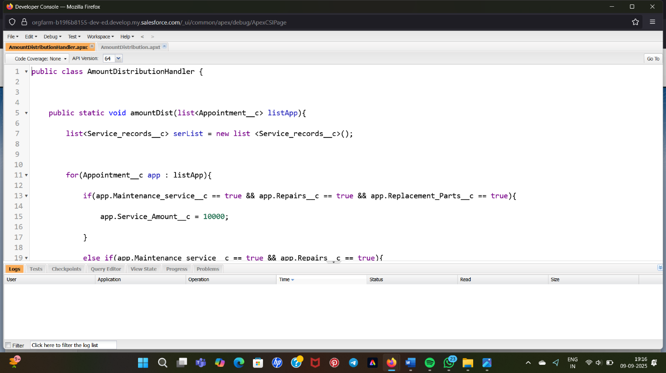

AmountDistributionHandler

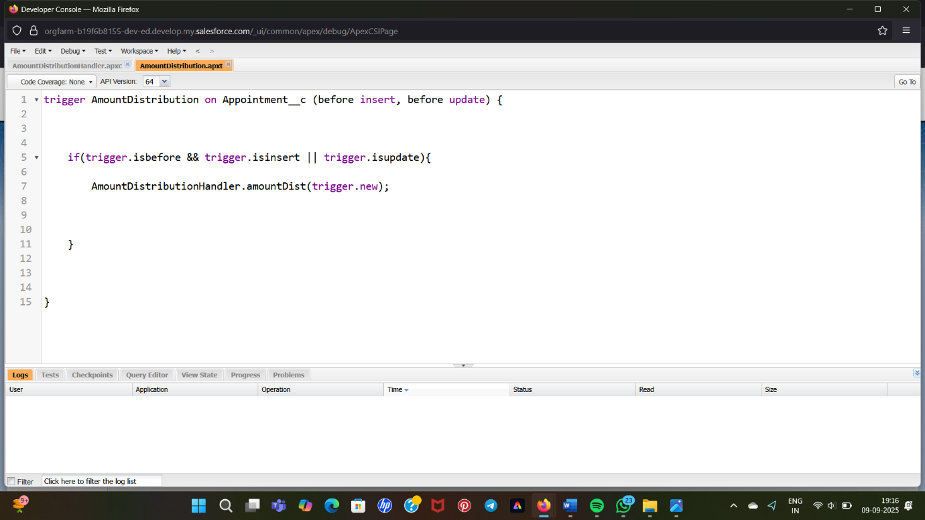

Reports

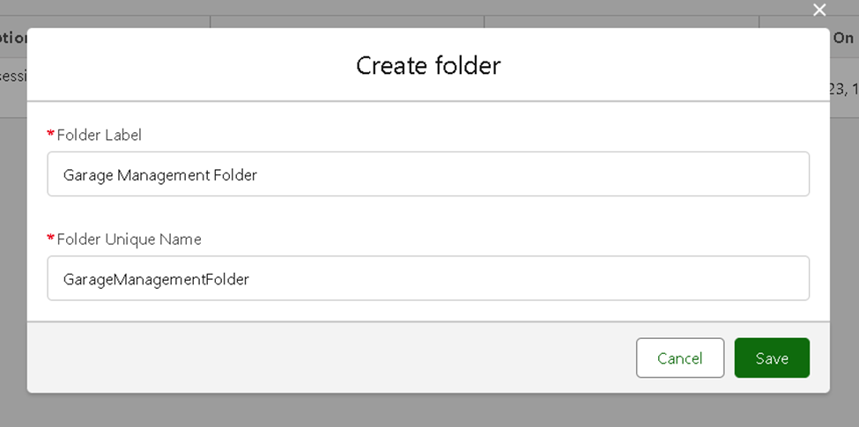

Create a Report Type:

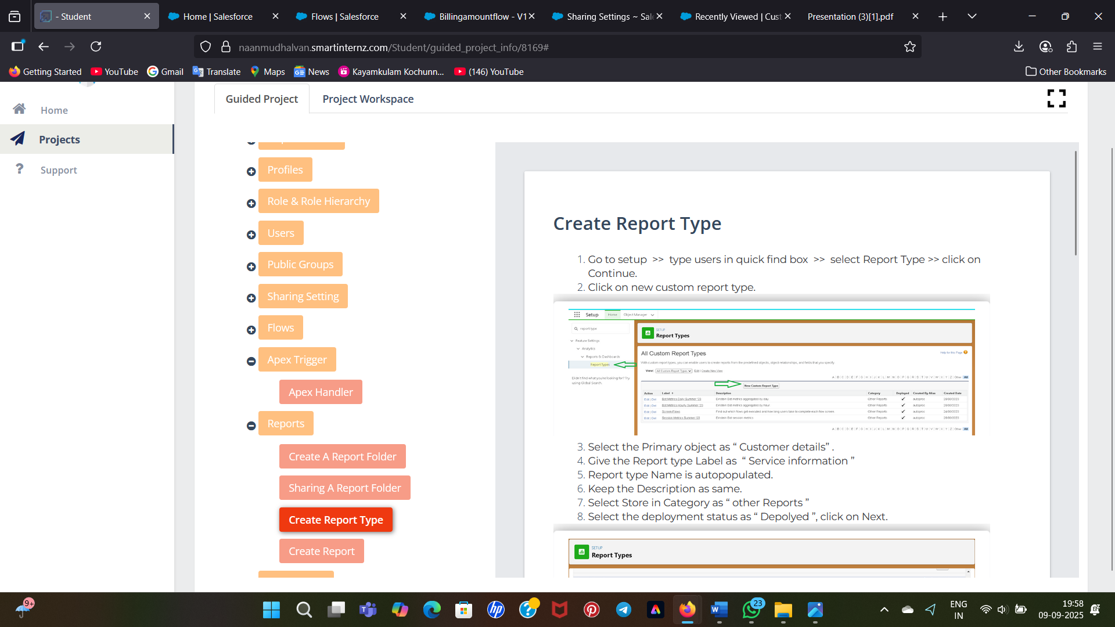

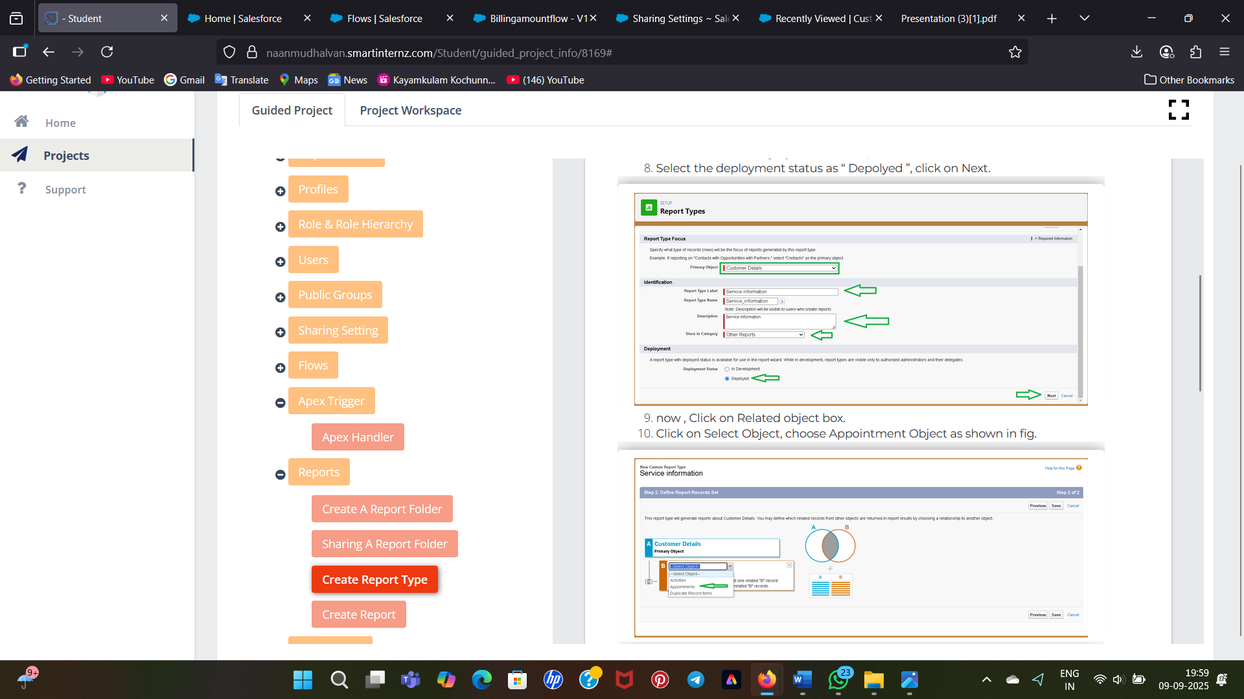

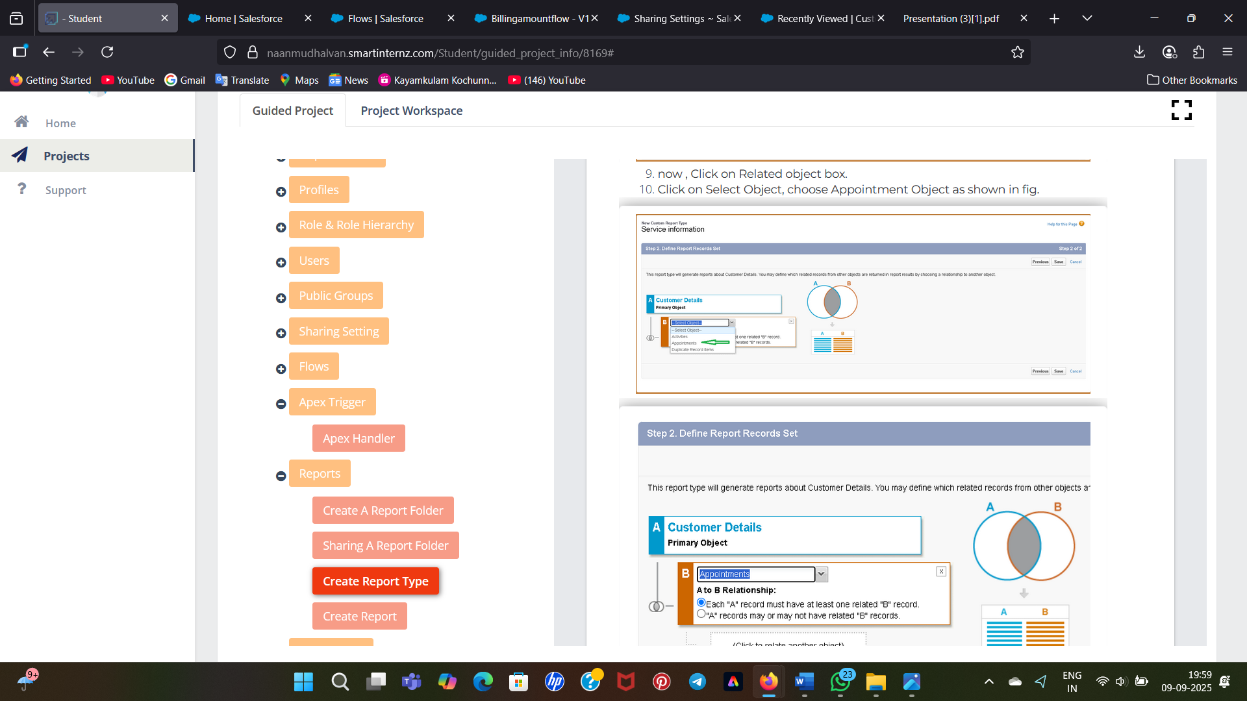

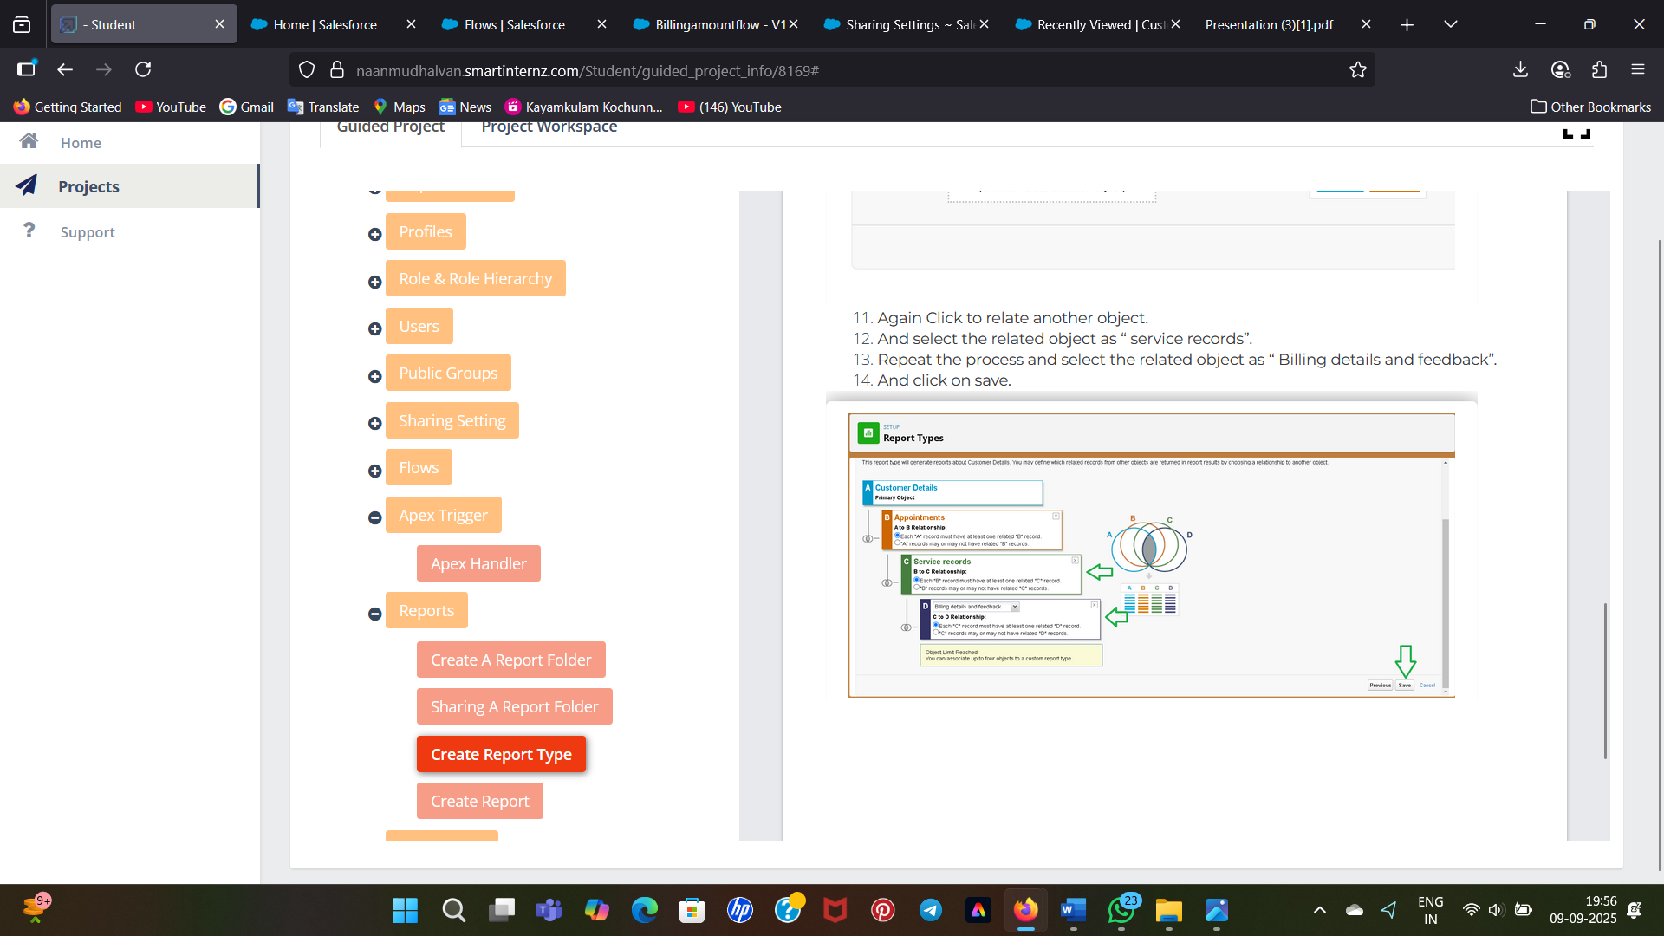

Created Folder

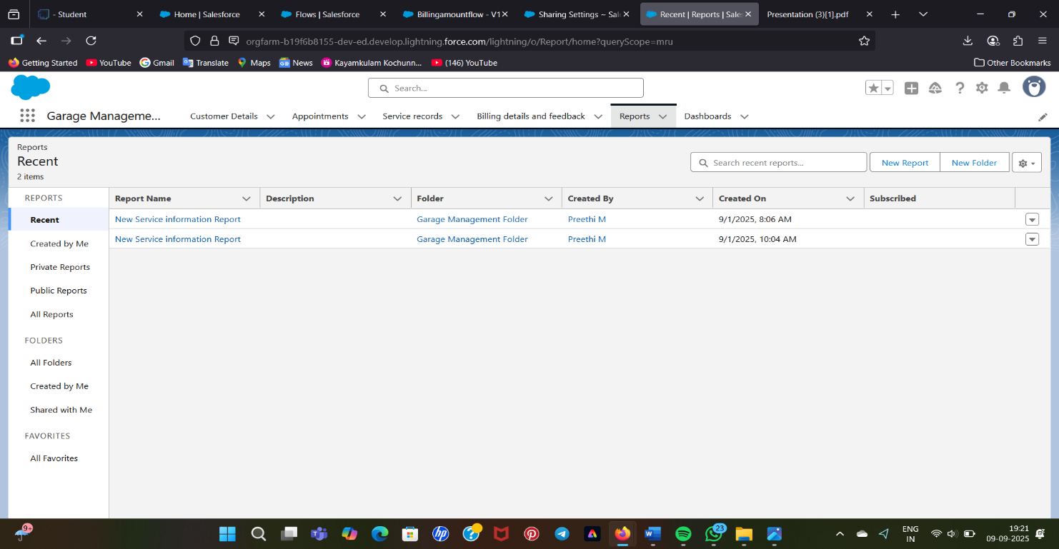

**Create Dashboard Folder**

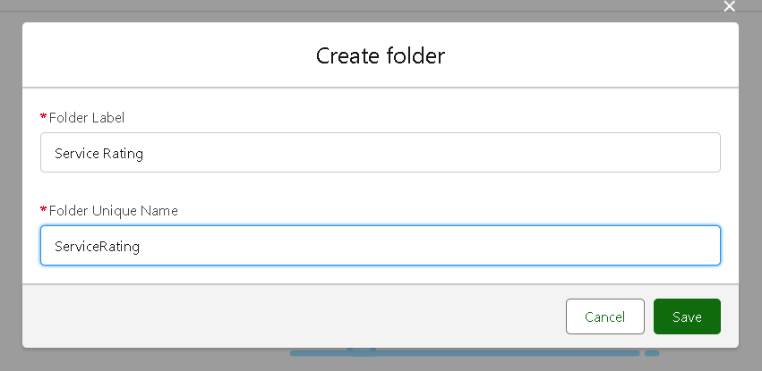

**Results**

**In Garage Management system app we have six fields they are;**

* **Customer Details**
* **Appointment**
* **Service Records**
* **Billing Details and feedback**
* **Reports**
* **Dashboard**

**Customer Details:**

Created Atleast 10 customer Details

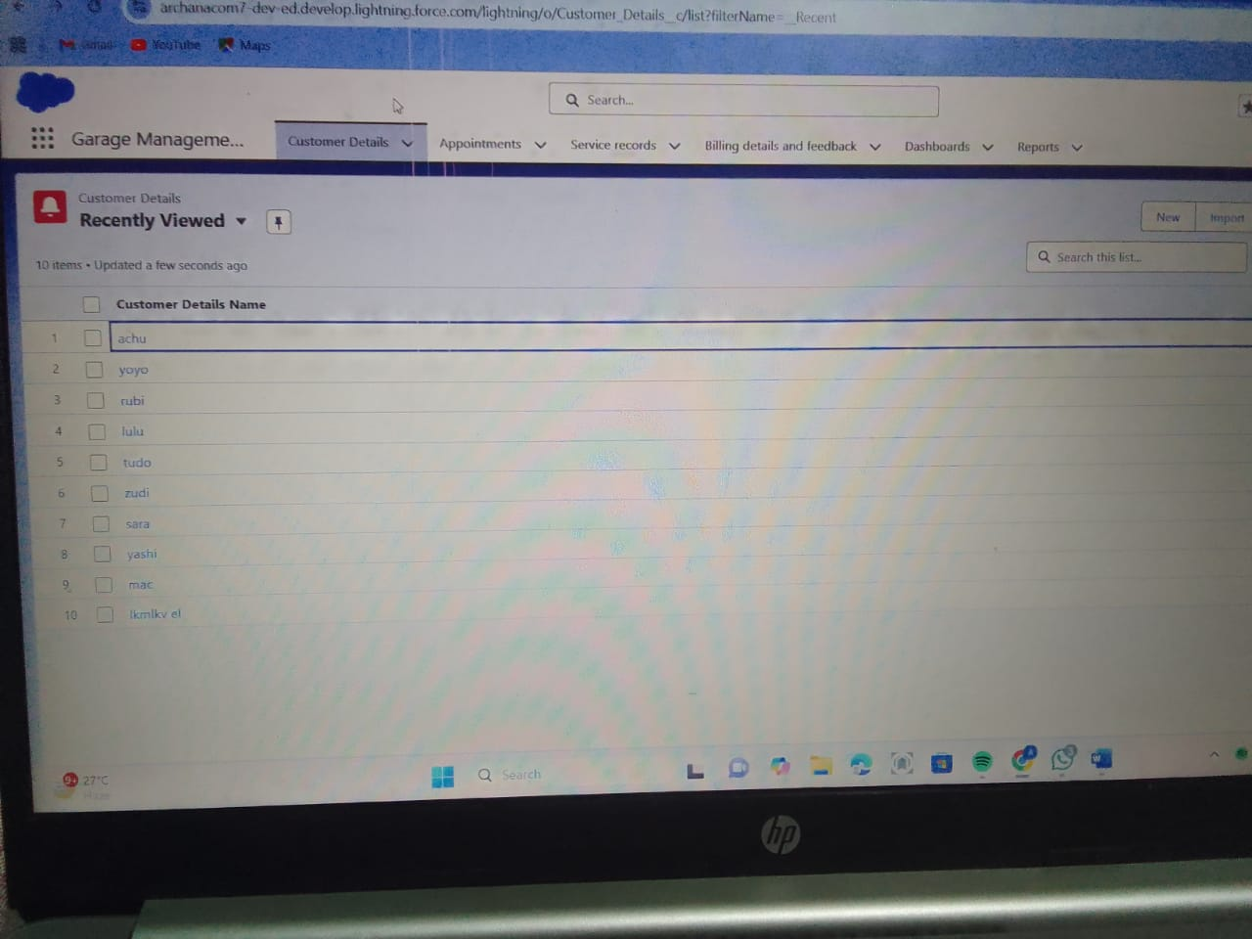

**Appointment:**

Created appointment for each customers

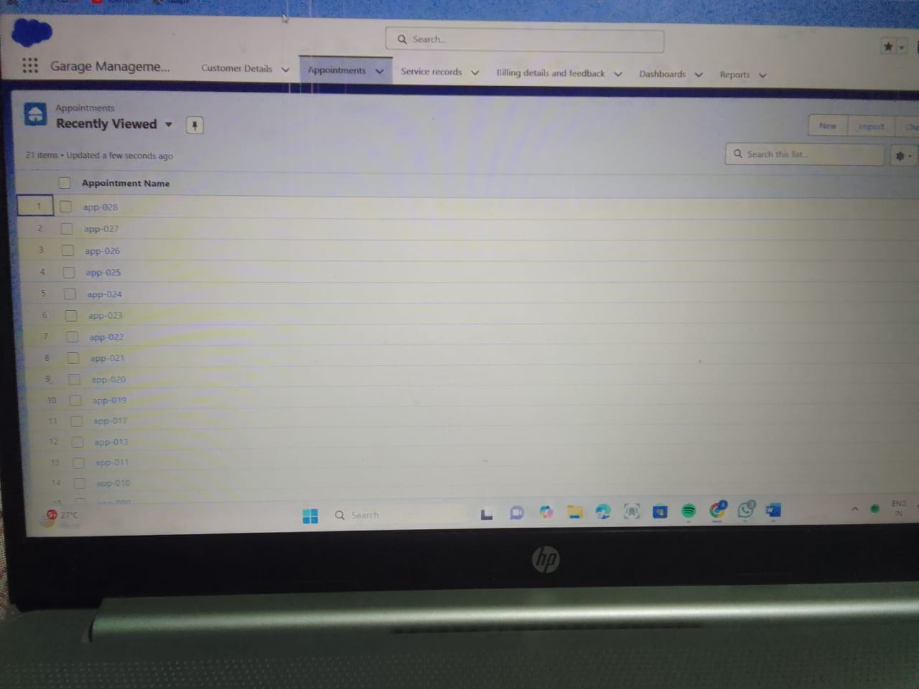

**Service Records**

Created service records for each customers

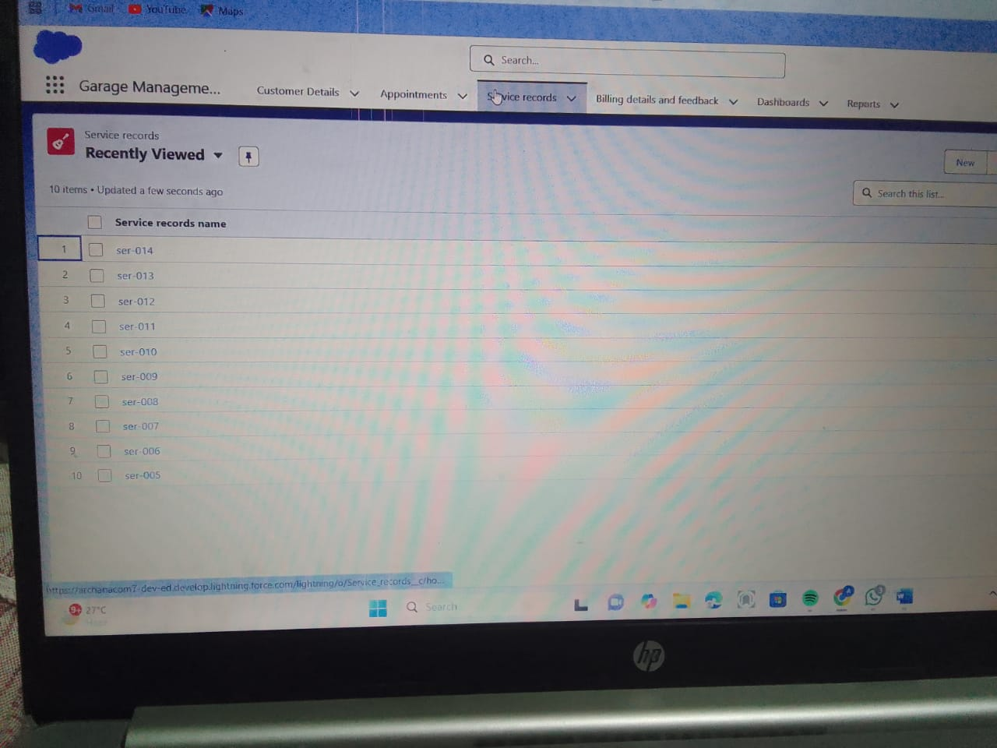

**Reports**

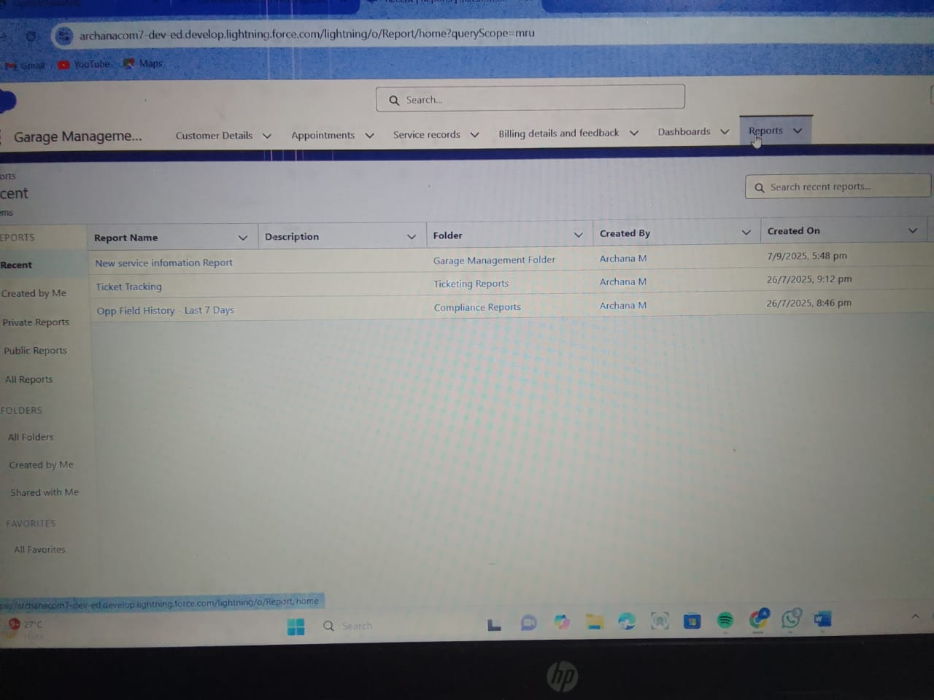

**Dashboard**

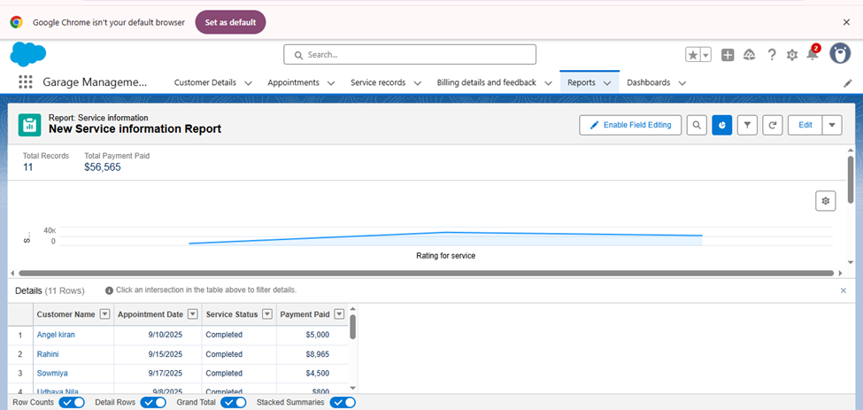

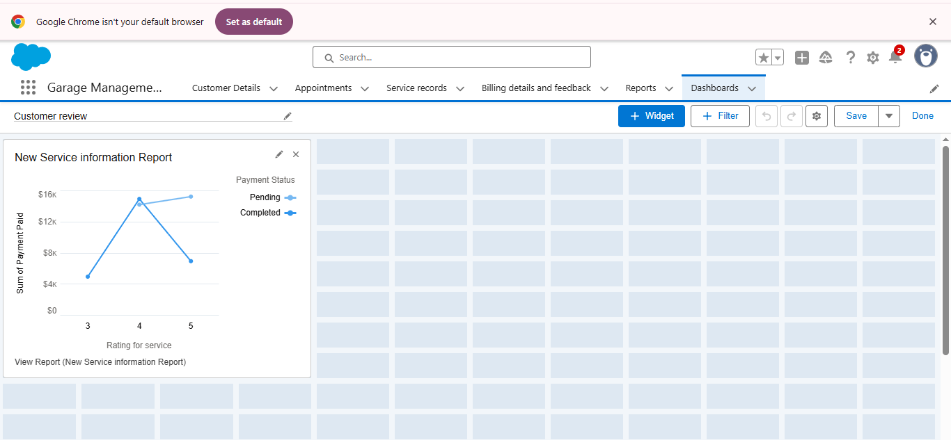

**Advantages and Disadvantages:**

**Advantages**

* Customization
* Cloud-based Acess
* Artificial Intellidence
* Reporting &Analytics

**Disadvantages**

* Expensive
* Cloud-only Deployment
* Complicated Implementation
* Poor Customer Support Reputation

**CONCLUSION:**

* Implementing a Garage management system in Salesforce can be a powerful solution for automotive service Centers and garages management system aims to transform the garage operations by technology for improved Efficiency ,customer satisfaction, and decision making.
* A garage management system can driven positive outcomes for garage operation and customer relationships.